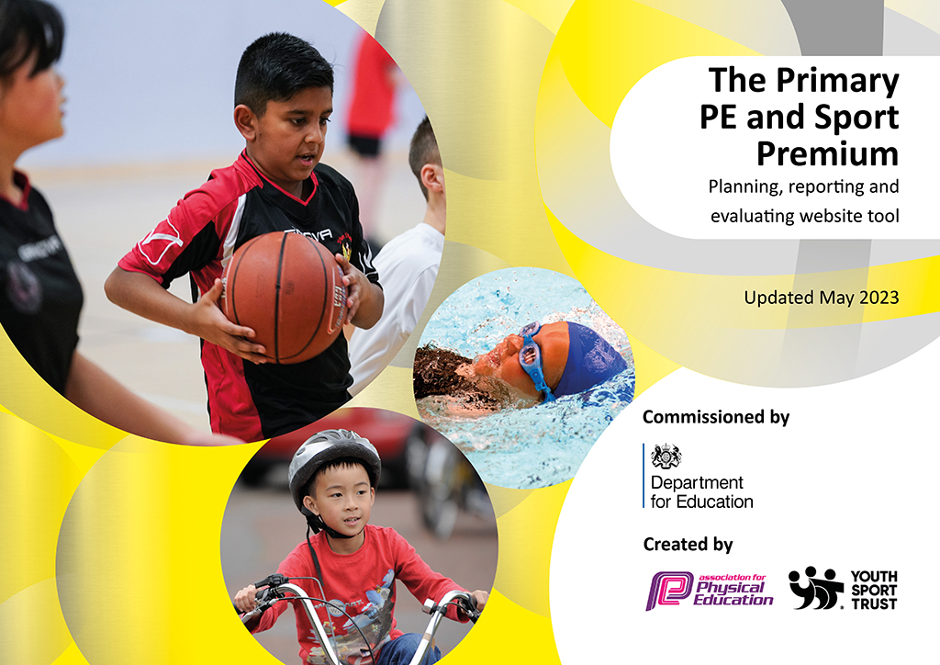
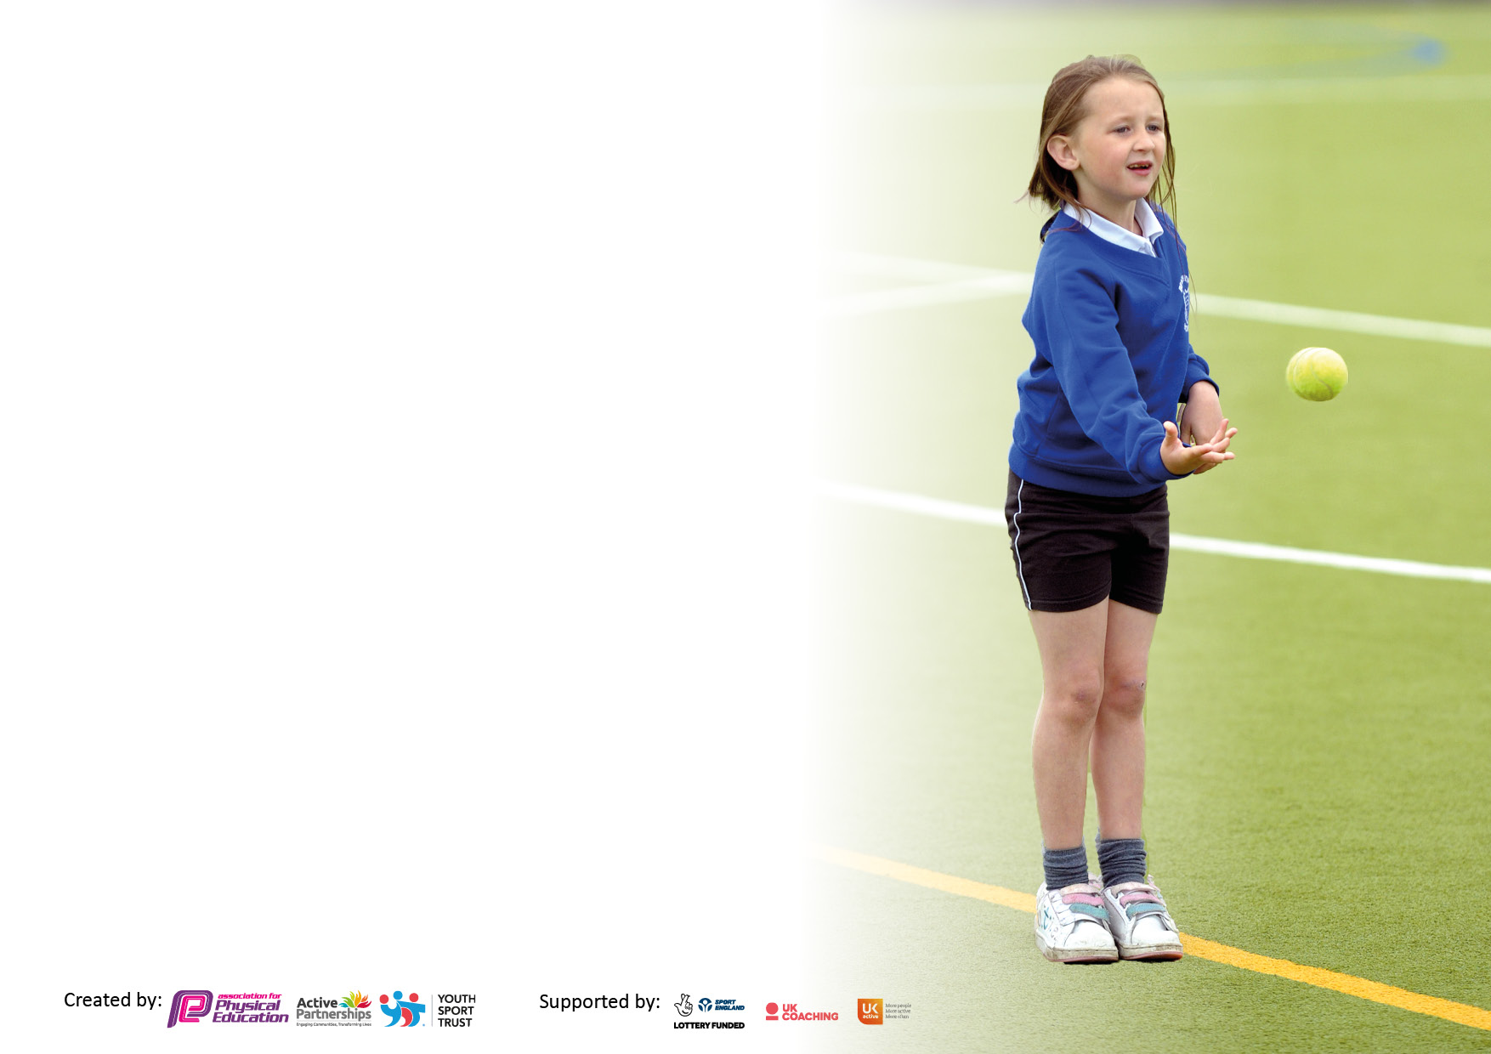

It is important that your grant is used effectively and based on school need. The Education Inspection Framework makes clear there will be a focus on ‘whether leaders and those responsible for governors all understand their respective roles and perform these in a way that enhances the effectiveness of the school’.

Under the Quality of Education Ofsted inspectors consider:
Intent - Curriculum design, coverage and appropriateness
Implementation - Curriculum delivery, Teaching (pedagogy) and Assessment
Impact - Attainment and progress

To assist schools with common transferable language this template has been developed to utilise the same three headings which should make your plans easily transferable between working documents.

Schools must use the funding to make additional and sustainable improvements to the quality of Physical Education, School Sport and Physical Activity (PESSPA) they offer. This means that you should use the Primary PE and sport premium to:

- Develop or add to the PESSPA activities that your school already offer
- Build capacity and capability within the school to ensure that improvements made now will benefit pupils joining the school in future years
- The Primary PE and sport premium should not be used to fund capital spend projects; the school’s budget should fund these.

Pleasevisitgov.ukfortherevisedDfEguidanceincludingthe5keyindicatorsacrosswhichschoolsshoulddemonstrate animprovement.Thisdocumentwillhelpyoutoreviewyourprovisionandtoreportyourspend.DfEencouragesschools to use this template as an effective way of meeting the reporting requirements of the Primary PE and Sport Premium.

We recommend you start by reflecting on the impact of current provision and reviewing the previous spend.

Schools are required to publish details of how they spend this funding, including any under-spend from 2021/2022, as well as on the impact it has on pupils’ PE and sport participation and attainment. All funding must be spent by 31st July 2023.

We recommend regularly updating the table and publishing it on your website throughout the year. This evidences your ongoing self-evaluation of how you are using the funding to secure maximum, sustainable impact. Final copy must be posted on your website by the end of the academic year and no later than the 31st July 2023. To see an example of how to complete the table please click HERE.

Details with regard to funding
Please complete the table below.

Total amount carried over from 2021/22 | £
Total amount allocated for 2021/22 | £
How much (if any) do you intend to carry over from this total fund into 2022/23? | £
Total amount allocated for 2022/23 | £17,750
Total amount of funding for 2022/23. To be spent and reported on by 31st July 2023. | £ 17,750
Swimming Data
Please report on your Swimming Data below.

Meeting national curriculum requirements for swimming and water safety.

N.B. Complete this section to your best ability. For example you might have practised safe self-rescue techniques on dry land which you can then transfer to the pool when school swimming restarts.
Due to exceptional circumstances priority should be given to ensuring that pupils can perform safe self rescue even if they do not fully meet the first two requirements of the NC programme of study
What percentage of your current Year 6 cohort swim competently, confidently and proficiently over a distance of at least 25 metres?  N.B. Even though your pupils may swim in another year please report on their attainment on leaving primary school at the end of the summer term 2022.  Please see note above | 91%
What percentage of your current Year 6 cohort use a range of strokes effectively [for example, front crawl, backstroke and breaststroke]?  Please see note above | 89%
What percentage of your current Year 6 cohort perform safe self-rescue in different water-based situations? | 89%
Schools can choose to use the Primary PE and sport premium to provide additional provision for swimming but this must be for activity over and above the national curriculum requirements. Have you used it in this way? | Yes/No

Action Plan and Budget Tracking
Capture your intended annual spend against the 5 key indicators. Clarify the success criteria and evidence of impact that you intend to measure to evaluate for pupils today and for the future.

Academic Year: 2022/23 | Total fund allocated: | Date Updated:
Key indicator 1: The engagement of all pupils in regular physical activity – Chief Medical Officers guidelines recommend that primary school pupils undertake at least 30 minutes of physical activity a day in school |  |  |  | Percentage of total allocation:
 |  |  |  | 53%
Intent | Implementation |  | Impact
Your school focus should be clear what you want the pupils to know and be able to do and about  what they need to learn and to  consolidate through practice: | Make sure your actions to achieve are linked to your intentions: | Funding allocated: | Evidence of impact: what do pupils now know and what can they now do? What has changed?: | Sustainability and suggested next steps:
To maintain high levels of activity during lessons during the day. | Provide at least 2 hours of physical activity every week. | Teach Active  £975 | Using Teach active weekly has allowed for children to become less sedentary during lessons which may result in these behaviours. Children often show high levels of engagement and participation in these areas in the curriculum and raises interest of groups of children who thrive in a multi-sensory approach to learning. | Continue to implement Teach Active on a weekly basis in Maths and English Lesson to reduce sedentary behaviours.
To ensure that children are participating in at least 30 minutes of physical activities daily. | Support staff and teachers have raised their knowledge of how to implement physical activity daily at breaktimes and lunchtimes. | £3,450 | As a result, most children will participate in an organized game during breaktimes and lunchtime (e.g. trim trail, cricket, rounders, football or a playground game). | Further invest in the opportunities at break time and lunch time by conducting pupil voice to continue to encourage high levels of physical activity at these times.
 | Premier Sport have provided all school pupils with 30 minute lunchtime clubs – EY Monday, KS1 Tuesday, KS2 Wednesdays). |  | Children have selected the clubs which they would like to have run at lunchtime through pupil voice. Therefore, engagement was high for these clubs, which changed half termly, to keep children interested and engaged in sports.
To ensure that Early Year environment supports the development of fine and gross motor skills. | The has been the purchase of a range of equipment and resources to improve the outdoor area to better support early years to develop their motor skills. This includes ensuring that there is enough equipment for the size of the cohort. | £4989.93 |  | Maintain the new equipment for the outdoor Early Years area.
Key indicator 2: The profile of PESSPA being raised across the school as a tool for whole school improvement |  |  |  | Percentage of total allocation:
 |  |  |  | 15%
Intent | Implementation |  | Impact
Your school focus should be clear what you want the pupils to know and be able to do and about  what they need to learn and to  consolidate through practice: | Make sure your actions to achieve are linked to your intentions: | Funding allocated: | Evidence of impact: what do pupils now know and what can they now do? What has changed?: | Sustainability and suggested next steps:
To raise the profile of sports and inspirational athletes across school. | A wide range of high-quality literature has been selected to be rolled out across school. A reading challenge will take place in each year group to launch the new texts and encourage engagement and knowledge of sports and athletes across the curriculum. | £2617.23 |  | Ensure that there is a reading challenge at least once every term to continue children’s engagement in sports through literature.
To raise the quality of teaching across the school to allow for clear and consistent progression within the curriculum from Early years all the way through to Key Stage 2. | The long-term plan on PE passport has been adapted to allow for clear progression through the years as well as providing them with a foundation of knowledge to encompass for future learning as they move through the school. |  | To raise the quality of teaching across the school to allow for clear and consistent progression within the curriculum from Early years all the way through to Key Stage 2. | Now teachers are becoming more confident with the teaching structure of PE Passport. Providing CPD training in subject specific areas to ensure that all staff can continue to develop their subject knowledge.
To raise the profile of sports and athletes in sports within school. |  |  |  | As the summer Olympic will be occurring in July 2024, we will ensure that they are able to engage with this significant event in school.

Key indicator 3: Increased confidence, knowledge and skills of all staff in teaching PE and sport |  |  |  | Percentage of total allocation:
 |  |  |  | 3%
Intent | Implementation |  | Impact
Your school focus should be clear | Make sure your actions to | Funding | Evidence of impact: what do | Sustainability and suggested
what you want the pupils to know | achieve are linked to your | allocated: | pupils now know and what | next steps:
and be able to do and about | intentions: |  | can they now do? What has
what they need to learn and to |  |  | changed?:
consolidate through practice:
To ensure that teachers have the planning support needed to teach PE lesson which support progress in the national curriculum. | PE Passport has been implemented across the school to provide a foundation of knowledge of quality Physical Education lessons which achieve the goals of the national curriculum. | £478.80 | Teachers are more confident when teaching physical education, ensuring that all children make expected progress and are challenged accordingly. This can be seen in the assessment data which shows 75% of children have made expected or more than expected progress. While 90% have made expected progress. | Engaging in CPD for the use of PE passport to ensure that staff continue to grow the confidence in the units, sports, skills and knowledge which they are teaching.
Key indicator 4: Broader experience of a range of sports and activities offered to all pupils |  |  |  | Percentage of total allocation:
 |  |  |  | 30%
Intent | Implementation |  | Impact
Your school focus should be clear | Make sure your actions to | Funding | Evidence of impact: what do | Sustainability and suggested
what you want the pupils to know | achieve are linked to your | allocated: | pupils now know and what | next steps:
and be able to do and about | intentions: |  | can they now do? What has
what they need to learn and to |  |  | changed?:
consolidate through practice:
Additional achievements:  To provide a broad range of sporting experiences to children throughout the whole school. | The long-term curriculum has been adapted to include a range of different sports for the children to experience. Due to this, resources have been purchased to ensure that the children have the experience which they need to have the full experience of a range of sports. | £3336.54 | Through the use of Pupil voice, they have said that they enjoy the range of sports which is provided throughout the curriculum and enjoy their PE lessons. | Assess the impact of the new LTP in this coming year to see if it has had a positive impact on children’s confidence and skills in each area of the PE curriculum.
To ensure that all pupils have the equipment which they need in order to become competent swimmers by the end of KS2. | As a school we have purchased basic swimming equipment which were a barrier for many children to go swimming on a regular basis to meet the requirements to become competent swimmer (swimming hats and swimming costumes/trunks) | £68.84 | Children will not be prevented from going to swimming practice due to not having access the equipment which they need to become successful swimmers. | To assess if the engagement of swimming is continuously raised through the access of the correct kit to participate.
To provide a range of sporting experiences for children across the curriculum. | The school will keep aside a budget provide children with the experience to take the children to a local sporting facility (Snowdome), so that they are able to experience winter sports. | £1833.66 | Providing children with a sporting visit which they may not usually access to broaden their experiences of sports. | To conduct a pupil’s voice on their experiences of physical activity.

Key indicator 5: Increased participation in competitive sport |  |  |  | Percentage of total allocation:
 |  |  |  | %
Intent | Implementation |  | Impact
Your school focus should be clear | Make sure your actions to | Funding | Evidence of impact: what do | Sustainability and suggested
what you want the pupils to know | achieve are linked to your | allocated: | pupils now know and what | next steps:
and be able to do and about | intentions: |  | can they now do? What has
what they need to learn and to |  |  | changed?:
consolidate through practice:
To make sure children should be well prepared to compete in the local community in a range of sporting events across the whole school. | Children have been able to experience a range of sports clubs at lunchtime which are linked to the sporing competitions which are happening in Tamworth. This has allowed children to be well prepared for the competitions and show good sportsmanship and resilience when they are competing. | £  Accounted for above | Children are beginning to value sports competitively. They are excited to engage in a range of sporting competitions within the local community as well as having many successes in sports. Including netball, none of the children had played the sport prior to the club and won in the Tamworth competition and got to compete in the county finals, as well as football where children were able to make it to the semi-finals in Tamworth. | Competitive sport needs to be more widely spread across school moving forward, to develop competitiveness in early years and key stage one – alongside key stage 2
To achieve the school Game Mark to show commitment and dedication to sports in the local community. |  |  | This year, Bird’s Bush has achieved Gold in the school game mark. Many children were able to take part in competitions within the local community on a regular basis.

Signed off by
Head Teacher:
Date:
Subject Leader:
Date:
Governor:
Date:

