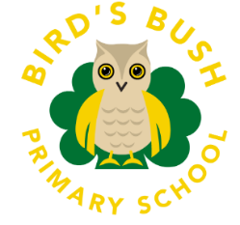

Bird’s Bush Primary School
SEND Code of Practice
How do we identify Special Educational Needs and Disabilities?
What Should I do if I think my child has Special Educational Needs?
What if my child has more complex or severe needs?
What if my child has medical needs?
How do we involve pupils and their parents/carers?
What support do we offer for children with SEND?
How do we adapt the curriculum so that it meets the needs of our children with SEND?
How will my child be included in activities outside the classroom including educational visits?
How accessible is the school environment?
How is the decision made about how much support my child will receive?
How will I be involved in discussions about and planning for my child’s education?
How is your child’s progress assessed and reviewed?
How do we ensure your child’s overall well-being is supported?
The Role of Adults in School
How will the school support your child at key transition points between key stages or new schools?
Who can I contact for further information?

Special Educational Needs Information Report

At Bird’s Bush Primary School, we believe that having high expectations and meeting every pupils’ needs is a shared responsibility. We understand that every teacher is a teacher of SEND. Therefore, we are committed to offering an inclusive curriculum to ensure the best possible progress for all our pupils regardless of their needs or abilities. The views of our children and their families are at the heart of everything we do.
We have a positive and enthusiastic approach to ensuring that we meet the needs of all children including those with Special Educational Needs and/or disabilities (SEND). We believe educational provision is underpinned by consistent high-quality teaching and timely intervention.

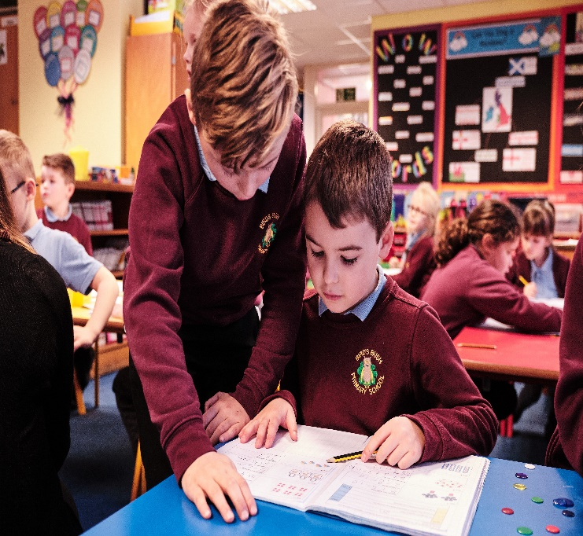
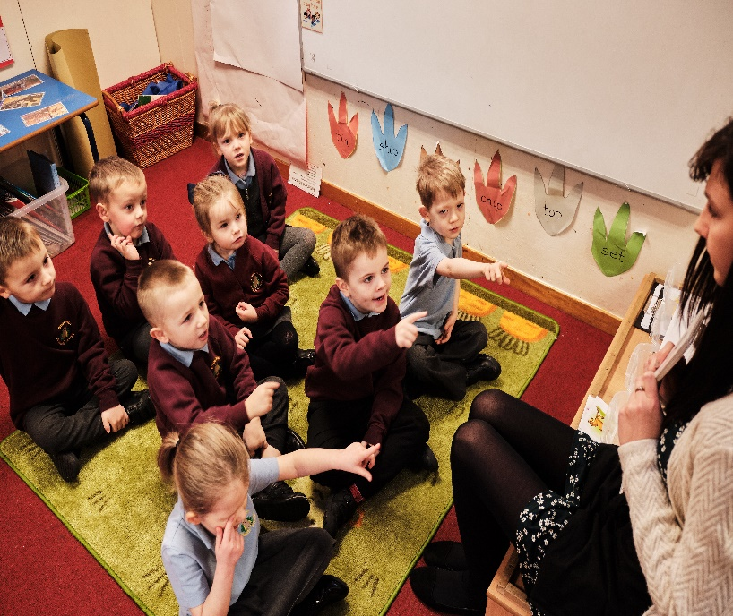

This document is to inform you of the types of support and provision available for your child at Bird’s Bush Primary School.
It will assist you in knowing who can help if your child needs additional support, and how this support can be accessed.
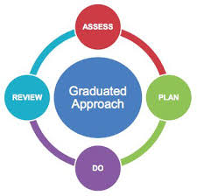

SEND Code of Practice

The SEND ‘Code of Practice’ (2014) states that there are four broad areas of need within Special Educational Needs. These areas and their meaning are as follows:
- Communication and Language
- Cognition and Learning
- Social, Emotional and Mental Health
- Sensory and/or Physical Needs
The table below details some difficulties that children may display, it is important to recognise that children may display difficulties or delays in one or more of the areas. We follow the Graduated Response guidance as stated in the Code of Practice.
Area of Special Educational Need or Disability
Relating to difficulties with:
Communication And  Interaction | Children and young people with speech, language, and communication needs (SLCN) have difficulty in communicating with others. This may be because they have difficulty saying what they want to, understanding what is being said to them or they do not understand or use social rules of communication. The profile for every child with SLCN is different and their needs may change over time. They may have difficulty with one, some or all the different aspects of speech, language, or social communication at different times of their lives.  Children and young people with ASD, including Asperger’s Syndrome and Autism, are likely to have difficulties with social interaction. They may also experience difficulties with language, communication, and imagination, which can impact on how they relate to others.
Cognition  And  Learning | Support for learning difficulties may be required when children and young people learn at a slower pace than their peers, even with appropriate differentiation.  Learning difficulties cover a wide range of needs, including moderate learning difficulties (MLD), severe learning difficulties (SLD), where children are likely to need support in all areas of the curriculum and associated difficulties with mobility and communication, through to profound and multiple learning difficulties (PMLD), where children are likely to have severe and complex learning difficulties as well as a physical disability or sensory impairment.  Specific learning difficulties (SpLD), affect one or more specific aspects of learning. This encompasses a range of conditions such as dyslexia, dyscalculia, and dyspraxia.
Social, Emotional and Mental Health | Children and young people may experience a wide range of social and emotional difficulties which manifest themselves in many ways. These may include becoming withdrawn or isolated, as well as displaying challenging, disruptive, or disturbing behaviour. These behaviours may reflect underlying mental health difficulties such as anxiety or depression, self-harming, substance misuse, eating disorders or physical symptoms that are medically unexplained. Other children and young people may have disorders such as attention deficit disorder, attention deficit hyperactive disorder or attachment disorder.
Sensory and/or physical needs | Some children and young people require special educational provision because they have a disability which prevents or hinders them from making use of the educational facilities generally provided. These difficulties can be age related and may fluctuate over time.  Many children and young people with vision impairment (VI), hearing impairment (HI) or a multi-sensory impairment (MSI) will require specialist support and/or equipment to access their learning.  Children and young people with an MSI have a combination of vision and hearing difficulties.  Some children and young people with a physical disability (PD) require additional ongoing support and equipment to access all the opportunities available to their peers.

The following pages detail further information in response to questions you may have about our approach to supporting and identifying SEND.

How do we identify Special Educational Needs and Disabilities?
All children starting our school will receive a home visit. This is an opportunity for parents and/or carers to share information regarding their child’s needs and education.
When beginning our school, all children are assessed. We use this information so that we can build upon their prior learning and knowledge, and it helps us to provide starting points for the development of an appropriate curriculum for all our children.
Children who join us from other schools are supported using information obtained from their previous school. We then use this to ensure that the curriculum is appropriately differentiated to meet their individual needs.
If the outcome of either of these means of assessment highlight that a child may have areas of need relating to a Special Educational Need/Disability, parents are contacted at the earliest opportunity. This provides further opportunities to discuss concerns and to enlist their active support and participation. If it is felt that additional support is required for their child, they may be placed on the Special Educational Needs (SEN) register and appropriate additional provision will be provided.
If an adult in school is concerned about the learning, progress, and wellbeing of any child, at any point in their education, they make the Inclusion Team aware of these concerns through a referral process. The Inclusion Team will then discuss the given concerns and offer advice and/or signpost the concerns to the most appropriate person within school. The child's progress is then monitored against the recommendations and advice provided through provisional targets, with the additional needs of the child being reviewed regularly. The outcomes of this initial target monitoring will be shared and discussed with parents.

If parents have their own needs, we encourage them to bring along a trusted friend or family member who can support them or we can offer support from our own family support worker in school.

What Should I do if I think my child has Special Educational Needs?
If you have concerns then contact your child’s teacher initially, Ms Kelly our SENCo or Mrs Hall our Inclusion Manager. The class teacher will then follow the referral process with the inclusion Team. Your child’s progress and provision will be carefully monitored as part of the process and evidence will be collected so that the Inclusion Team can decide what type of support your child may need. The class teacher will keep you informed throughout the process.

Working with other professionals to support your child’s Special Educational Needs.
We have an inclusion team that includes the SENCo (Ms Kelly) Inclusion Manager (Mrs Hall) and who are available to offer support and advice or signpost parents in the right direction to access outside agencies. The inclusion team meet regularly with the headteacher (Mrs Day) to review the progress and provision of all the SEND children.
What does the local offer provide?
Staffordshire Local Offer provides information in one place for children and young people aged 0-25 with special educational needs and disabilities (SEND), their parents/carers and professionals.
The Local Offer includes information on local services to help children, young people, parents and carers make choices about the support they receive.
At times it may be necessary to consult with outside agencies to receive their more specialised expertise.
Local Offer - Staffordshire County Council

The agencies used by the school include:
- Tamworth SEND Blue Hub  - Autism Inclusion Team  - Educational Psychologist  - Behaviour Support Service  - Malachi  - CAMHS (Child & Adolescent Mental Health Service)  - Speech & Language  - Occupational Therapy | - 0-19 Health Hub  - Children’s Services  - Educational Mental Health Team  - Two Rivers Outreach Service  - Corner Post Education Centre  - Saplings  - Elements SEMH support  - Emotion Coaching UK  - Paediatrician

What if my child has more complex or severe needs?
Most children and young people with SEND will have their needs met within school. When it is considered that a child may need further special educational provision and if their needs are more complex, we would consider the option of requesting the Local Authority complete an assessment to support the application of an Education Health and Care (EHC) Plan. This process would include a referral to the local SEND and Inclusion Hub and parent consent would be required. At this stage we would need to gather evidence from a range of sources to support the application.

This assessment may lead to an EHC Plan if your child requires additional support beyond that provided through SEND School Support. An EHC Plan looks at all the aspirations and needs that a child or young person has within education, health and care. Parents and/or Carers are involved throughout this process to decide what outcomes are required, and to identify what is needed to achieve those outcomes. We also strive to ensure the child’s voice is represented as part of the process.
The purpose of an EHC plan is to ensure educational provision meets the special educational needs of the child and to secure the best possible outcomes for them to prepare them for adulthood.

What if my child has medical needs?
If a child has a medical need, then a detailed Individual Healthcare Plan will be compiled by the Inclusion team in consultation with parents/carers. These are discussed and shared with all staff involved with the child.

Where necessary and in agreement with parents/carers medicines are administered in school where a signed medication form giving consent is completed and held at the office.

Occasionally, a child’s needs may need further support requested through an Education and Health Care Plan. (EHCP)

How do we involve pupils and their parents/carers?
At Bird’s Bush we value the importance of working in partnership with parents/carers to support each child’s well-being and learning needs.
We have an open-door policy to allow parents to contact their child’s class teacher with ease. Parents are invited to become involved in school life as much as possible. In addition, if your child is identified as having special educational needs and has an Individual Education Plan (IEP), you will be invited to meet with the SENCO and your child’s class teacher to discuss their targets and how best to support your child to achieve them, this includes how parents can provide support at home with these targets also.

What support do we offer for children with SEND?
Some children may need an Individual Education Plan (IEP), a Care Plan or a 1-page profile. Each plan will be agreed by the class teacher, parents, and child with support from the SENCo. All plans are adapted accordingly to suit the child’s individual needs. Individual targets are set. Support provision will vary depending upon the needs of the child. Targets are agreed with the children and parents. Copies of plans will be given to parents. We regularly evaluate the effectiveness of the provision made as part of the ongoing assess, plan, do, review cycle.

If a child has needs related to more specific areas of their education or social skills, such as spelling, handwriting, maths, and English skills etc. then that child may be placed in a small intervention group or wider adjustments may be made within the classroom whereby the child will have access to personalised supporting resources. Intervention will usually be run by our teaching assistants or the class teacher. The length of time of the intervention will vary according to need. The success will be regularly reviewed by all involved to check how effective the provision has been to inform future planning. If you have any queries related to the interventions, please do not hesitate to contact the class teacher or the SENCo.

Pupil Progress Meetings are held every half term. In these meetings, the class teacher meets the Senior Leaders to discuss the progress and provision of the children in their class. This shared discussion may highlight any potential problems in order for further support to be planned. The SENCo is involved in all of the meetings to enable a clear focus on SEND children within the meetings.

Occasionally, a child may need more expert support from an outside agency such as the Paediatrician, Speech Therapists, CAMHS, Autism Outreach Team etc.

With parents’ permission, referrals are made. After a series of assessments, a programme of support is usually provided to the school and parents/carers.

A teaching assistant may be allocated to work with the child in a 1-1 or small focus group to target more specific needs.

If appropriate specialist equipment may be given to the child e.g. reading rulers, coloured overlays, writing slopes or pen/pencils grips.

How do we adapt the curriculum so that it meets the needs of our children with SEND?
When we identify a child as having a special educational need their work will be adapted by the class teacher to enable them to access the curriculum more easily. All staff are familiar with a variety of approaches to teaching and learning, which means that we can adapt teaching approaches and resources to meet the needs within each class.
My child’s targets are well suited to his needs and he should achieve them too.
Parent
This may involve:
- Small group or individual intervention.
- Emotional or pastoral support/intervention to manage their own emotions and behaviour.
- Adapting the type and length of instructions given.
- Provide alternative resources that will support them to be more independent.
- IEP targets specifically set for each child.
- Implementing advice and recommendations from outside agencies.
- Extra support from an adult, when appropriate.

How will my child be included in activities outside the classroom including educational visits?
We try to ensure every child can access all the activities in and outside of the classroom including educational visits; we would look at the child’s individual needs and plan accordingly with the parents. Risk assessments are carried out and procedures are put in place to enable all children to participate. A health and safety risk assessment may suggest that that an intensive level of 1:1 support is needed in addition to the usual school staff.

How accessible is the school environment?
We are committed to providing an accessible environment which values and includes all children, staff, parents, and visitors. The layout of our building does create a few areas which are not easily accessible for people with physical disabilities. However, as a school

we are happy to discuss individual access requirements to support this. Please refer to our Accessibility Plan which is on our school website. School Policies | Birds Bush Primary School

How are the school’s resources allocated and matched to children’s special educational needs?
The SEN budget is allocated each financial year. The money is used to provide additional support or resources dependant on an individual’s needs.

The additional provision may be allocated after discussion with the class teacher at child progress meetings or if a concern has been raised by them at another time during the year.

Further support or resources may be allocated to your child following assessments by school staff or outside agencies.

Funding may be used to buy in specialist support (e.g. Educational Psychologist).

Funding generated through Pupil Premium are used to support that child’s learning.

How is the decision made about how much support my child will receive?
The decision about the type of support your child will receive will be made by the Senior Leadership/Inclusion team, the SENCo and the parents together. Provision will be closely monitored. This support may take the form of additional individual or small group support in class or in other intervention groups tailored to your child’s needs.
During their school life, if further concerns are identified due to the child’s lack of progress or well-being then other interventions will be arranged.

How will I be involved in discussions about and planning for my child’s education?
We value the contributions parents/carers make in supporting their child at school.

These may be through:

- discussions with the class teacher

- during parents’ evenings and termly reviews

- during discussions with Mrs Kelly or Mrs Hall

- during discussions with other professionals

- parents are encouraged to support on their child’s IEP with possible suggestions that could be included.

How is your child’s progress assessed and reviewed?
Teachers use information from a range of sources to inform their monitoring of children’s achievement. Sources include: work in children’s books, interviews with the child and results from termly assessments.
In collaboration, the school leadership team and SENCO monitor the progress of all groups of pupils half termly, discussing what adaptations/intervention is needed to support each child to make better than expected progress from their individual starting points.
You will be able to discuss your child’s progress at Parents Evenings and review meetings. Class Teachers will set termly and end-of-year targets which will be shared with you. Appointments can be made to speak in more detail to the class teacher or SENCO, by contacting school. We have an open-door policy and parents are welcome to contact school at any time to discuss issues. If teachers and staff agree that it is necessary, a home-school book can be implemented.

IEPs are reviewed at least termly. Targets are usually set by the class teacher but Parents/carers as well as children are encouraged to contribute to the targets and strategies.
I keep my targets with me for every lesson and when I have done something well in lessons I add it to my IEP. I like to share this with the teachers.

How do we ensure your child’s overall well-being is supported?

Our School is an accredited Emotion Coaching Organisation and Mrs Hall is an accredited ELSA (Emotional Literacy Support Assistant)
At Bird’s Bush, we recognise that behaviour is communicative and often reflects an emotion or feeling. Emotion Coaching is grounded in the belief that we are able to develop our ability to self-regulate our emotions and behaviour. Adult and child relationships are integral for this to occur. Through co-regulation of feelings, children learn to become more independent and develop self-regulation.
The regulation station helps me when I’m frustrated or scared. It helps me to calm down so I can do my learning. Sometimes I go under the table and that helps me but my teacher doesn’t mind because she talks to me and that helps me too.
The adults talk to me about my feelings and that helps me understand what is happening to me and it helps.

The Role of Adults in School
It is the responsibility of class teachers and TAs to develop empathetic relationships with pupils and ensure that school expectations are applied fairly in their classes. They expect their classes to behave in a responsible manner whenever the children are in their care and follow school policy in the prevention of bullying. The class teachers have high expectations of the pupils with regard to behaviour and strive to ensure that all pupils work to the best of their ability. The class teacher is a social, emotional, and learning role model for pupils. Additionally, they help pupils to co-regulate to achieve high expectations when necessary.
We use Emotion Coaching to support children to understand, regulate and reflect on their behaviour.
Step 1 -Recognising the child’s feelings and empathising with them.
Step 2 - Label the feelings and validating them (validating = let the child know why they might be feeling like this and that this is okay)
Step 3 -Set limits on the behaviour (if needed)
Step 4 - Problem-solve with the child.
We have Regulation Stations and safe spaces established across the school for children to use to enable them to self-regulate when they are experiencing difficult feelings. A few children with an identified social and emotional mental health need have access to their own personalised safe spaces.
Other support includes:
Nurture provision.
Home-School link support.
Behaviour and Attendance is monitored by the Inclusion Team and support is offered as appropriate.
PSHE curriculum
We also have adults who are trained in delivering Speech and Language, Precision Teaching, Emotional Literacy Support and Read Write Inc Fast Track Tutoring.
All staff are trained at Level 1 for Autism Awareness.

WE WORK CLOSELY WITH OUTSIDE AGENCIES AND OUR COLLEAGUES ACROSS PERRYHALL MAT TO PROVIDE ONGOING CONTINIOUS PROFESSIONAL DEVELOPMENT FOR ALL STAFF.

How will the school support your child at key transition points between key stages or new schools?
Bird’s Bush Primary school understands what a stressful time moving school can be. Therefore, we have put strategies are in place to enable the child’s transition to be as smooth as possible.

These include:

On entry: -
A planned programme of visits in the summer term for children starting in September including “Play and Stay” visits with parents/carers and a visit to their new class (without parent/ carer).
- Parent/carers are invited to a meeting at the school so that they know what to expect and are encouraged to share any concerns with the school.
- Our Foundation Stage teacher visits all children in their pre-school setting. Where concerns are raised, Ms Kelly (SENCO) may also visit the setting and a meeting with parents to discuss any issues may be arranged.
- In some circumstances individual arrangements may be made for starting school such as starting part time if necessary.
- Additional days can also be arranged if needed.

Transition through the school: -
A visit to their new class in July.

Information sharing sessions between year group teachers.

The class teacher is always willing to meet parents/carers prior to the child moving to their class. We have Parents’ Open Afternoon every summer term.

Secondary transition: -
Opportunities to work with local secondary schools are actively encouraged so that children are familiar with them. This occurs throughout the time at primary school.
Secondary school staff visit children prior to them joining their new school.

Ms Kelly (SENCO) meets the SENCOs from the secondary schools to pass on information regarding SEN children.

Ms Kelly (SENCO) arranges an extra visit for those SEN children who need/want one prior to transition days.

Children attend transition day’s particular to the school they are going to.

Mrs Hall and The Educational Mental Health Teamwork with children anxious about the move. This provides them with the opportunity to discuss any concerns they may have.

Mid-year transition
Our induction for children arriving mid-year includes: -
Currently we give all children a tour of the school with their parent/carer.

Introduce children to their new teacher and show them where they will put their coats etc.

Agree the start date. In certain circumstances, such as the child not having attended school before, special starting arrangements may be agreed.

Contact the previous school for the child’s records. Where there are concerns the
SENCo will be contacted by phone.

Who can I contact for further information?

In the first instance, parents/carers are encouraged to talk to their child’s class teacher.
For pupils with SEND, further information and support can be obtained from the SENCo.
Mrs Kelly-Special Educational Needs Co-ordinator (SENCo)
The designated teacher for looked after children is Jo Davies.
Ann Brown– Governor with responsibility for SEND.

Michelle Day – Headteacher

They are contactable on: 01827 214666 or via e-mail s.office@perryhallmat.co.uk

Bird’s Bush Primary School pay due regard to all relevant
Legislation and guidance including the SEND Code of Practice (2014), the
Equality Act (2010) and the Children and Families Act (2014)

Parents can raise concerns about SEN provision by contacting their child’s class teacher, SENCo, a member of the leadership team or the Headteacher. If the concern is not resolved informally, parents may lodge a formal complaint. The procedure for lodging a formal complaint is contained within the complaints policy.
Academy Complaints Policy (perryhallmat.co.uk)
Trust-Anti-Bullying-Policy (perryhallmat.co.uk)

