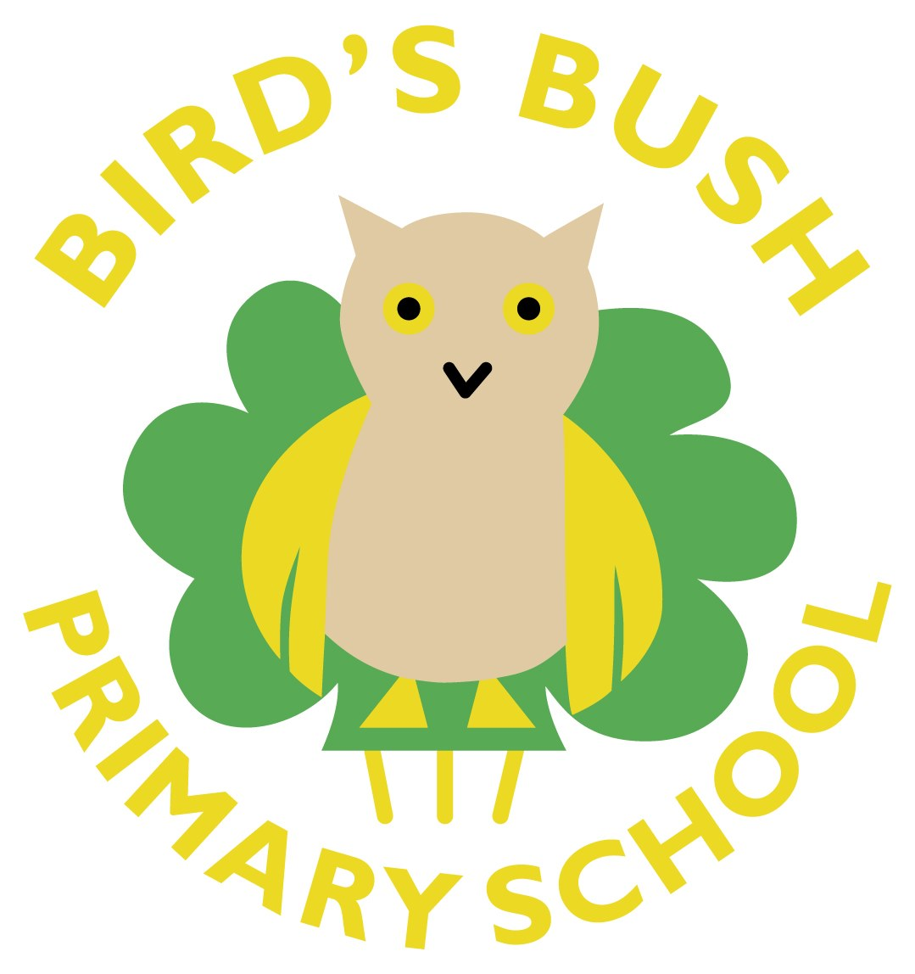

09.07.21 - Bird's Bush News
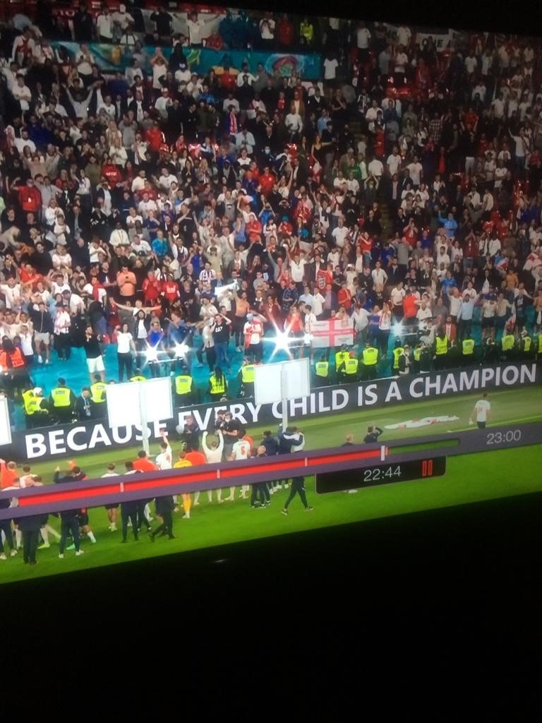
1 - Even the England Team celebrate with Bird's Bush Champions!
WOW! WHAT A GAME!!!!!!!!
If/When England win on Sunday night we will have a non-uniform celebration day on Monday - Football tops are allowed on this occasion. We would love a donation of £1 to help towards school funds please, Denese will collect at at the gate. GOOD LUCK ENGLAND!!!
Win or lose we will be celebrating with ALL DAY BREAKFAST on the Menu on Monday - because we love it!

Wow! What an interesting week that was - not at all what we had expected. Public Health are now on my speed dial. They said we are lucky to have got so far into the year without any bubble closures! Thank you for your patience and understanding, hopefully this will be the last time with the rules changing again.
We will not be moving away from our bubbles on 19th July - we're going to wait until September - it's 2 days and the children are used to the routines and procedures we have in place.
Children finish on Tuesday 20th July at 1.15pm
Inset Days
Wednesday 21st July 2021

Transition
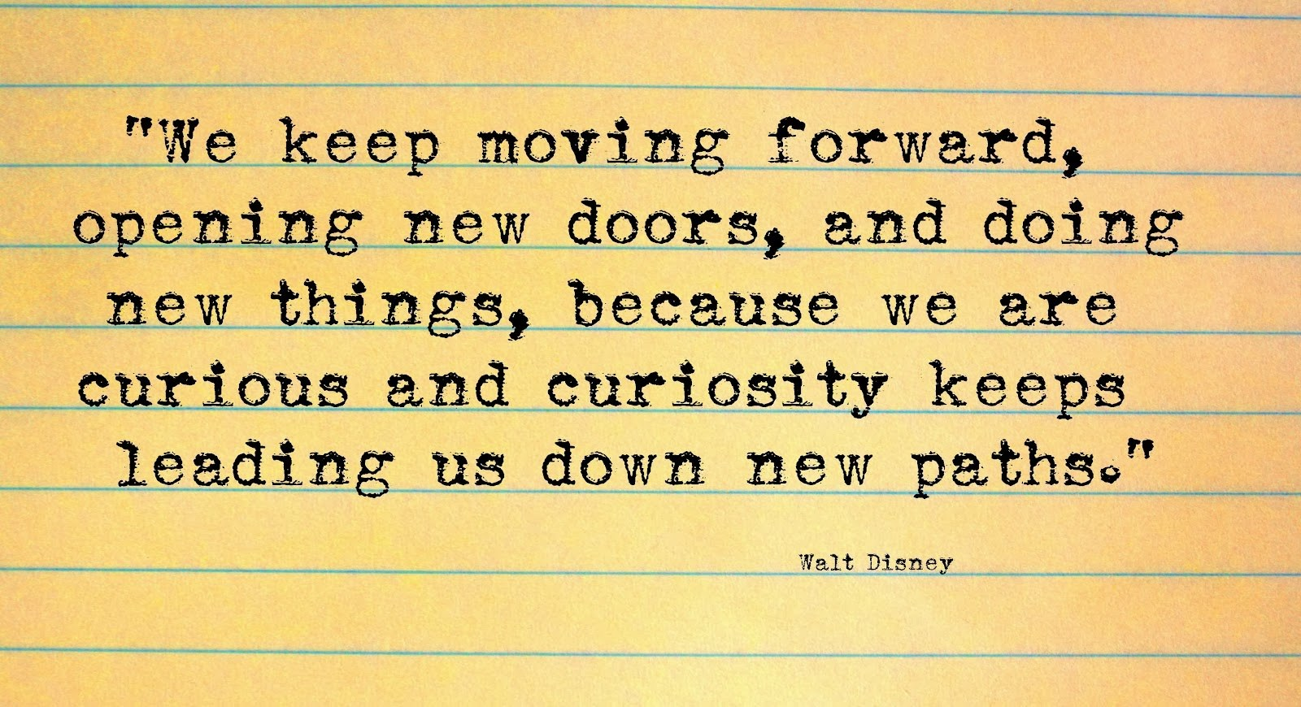
This morning we had a transition assembly where all of the children were introduced to their teacher for September - there were some very surprised and some very happy faces on screen! We are delighted to welcome Miss Francis, Miss Behan and Mr Jordan to the team and want to say a big thank you and good luck to Mr Fowler as he moves on to pastures new.
Most children already know their "new" teacher well and this should help remove any worries for coming back in September.
We have changed the structure in school to support transition this year, Reception, Year 1, Year 2 and Year 3 will be the lower school phase led by Miss Collins. To make this team work even better, Year 3 will be remaining in the same area as Year 1 & 2 rather than moving across the hall.
By doing this it also means that we can develop our very own sensory room/nurture base in the spare classroom. We are very excited about this and know that it is going to be a great support for many children.
SUMMER RAFFLE
We are having a summer raffle with some wonderful prizes to be won. Tickets can be bought on Parent Pay or by sending money in a sealed bag/envelope and handed in at the gate. Tickets will be virtual so you don't need paper tickets - we put them straight in the box with your name on. Tickets are £1 each.
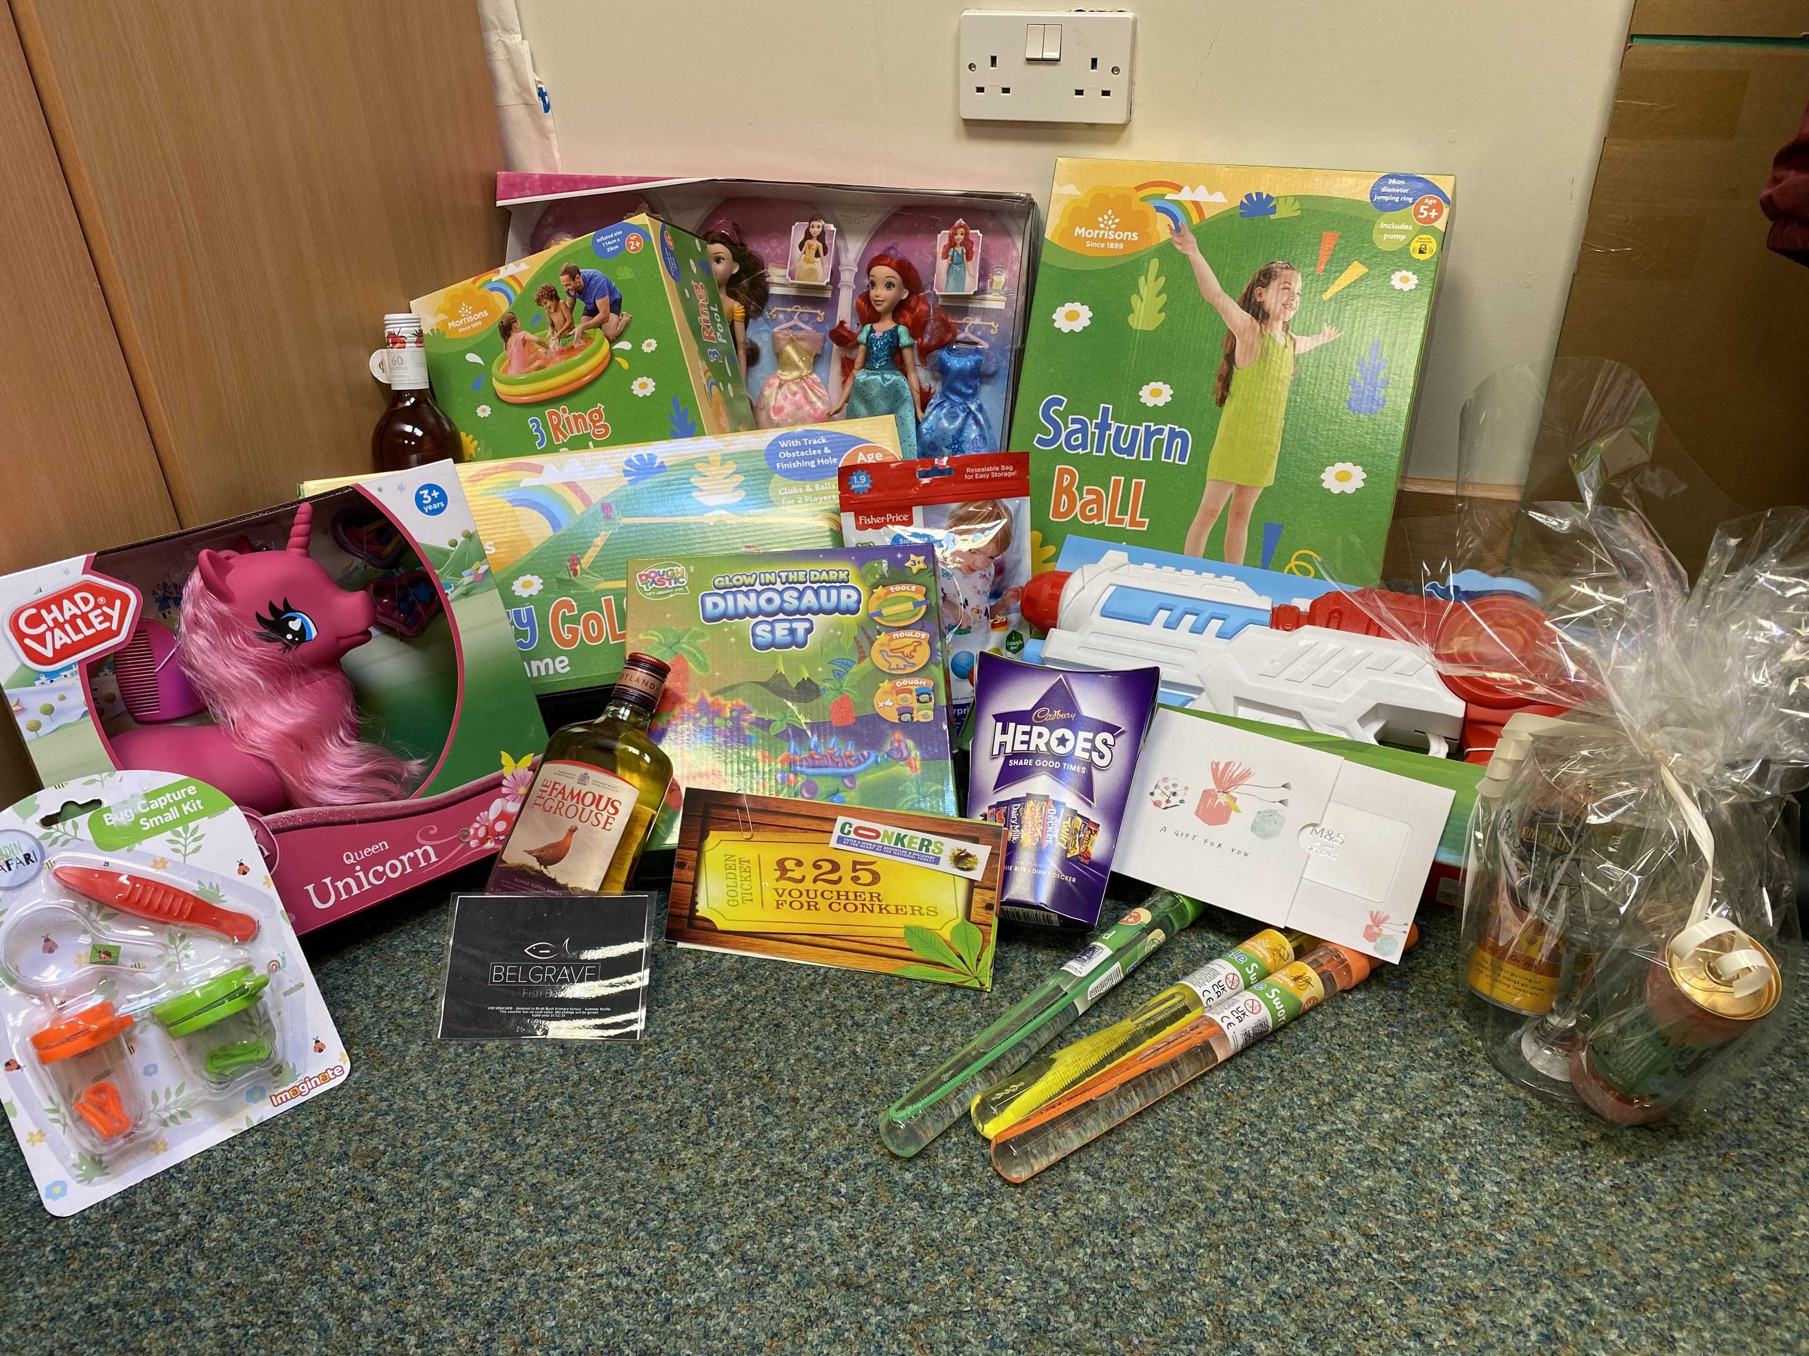

Staffing September 2021
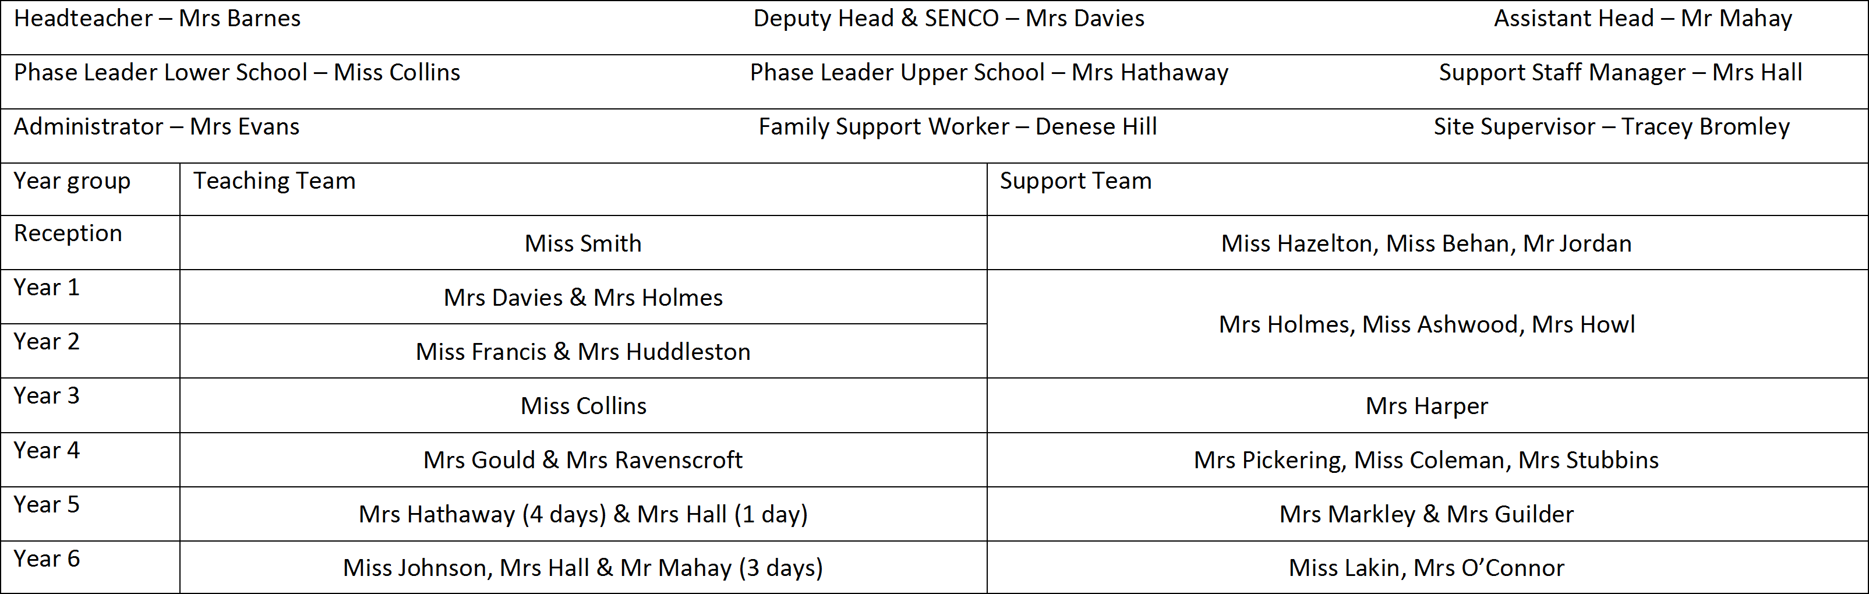

Welcome to September 2021 presentations
All presentations have similar content and you may want to pause the video playing to read though some pages.
All can be accessed on the website too - Transition presentations
Holiday Homework activity grids will be published next week on the website
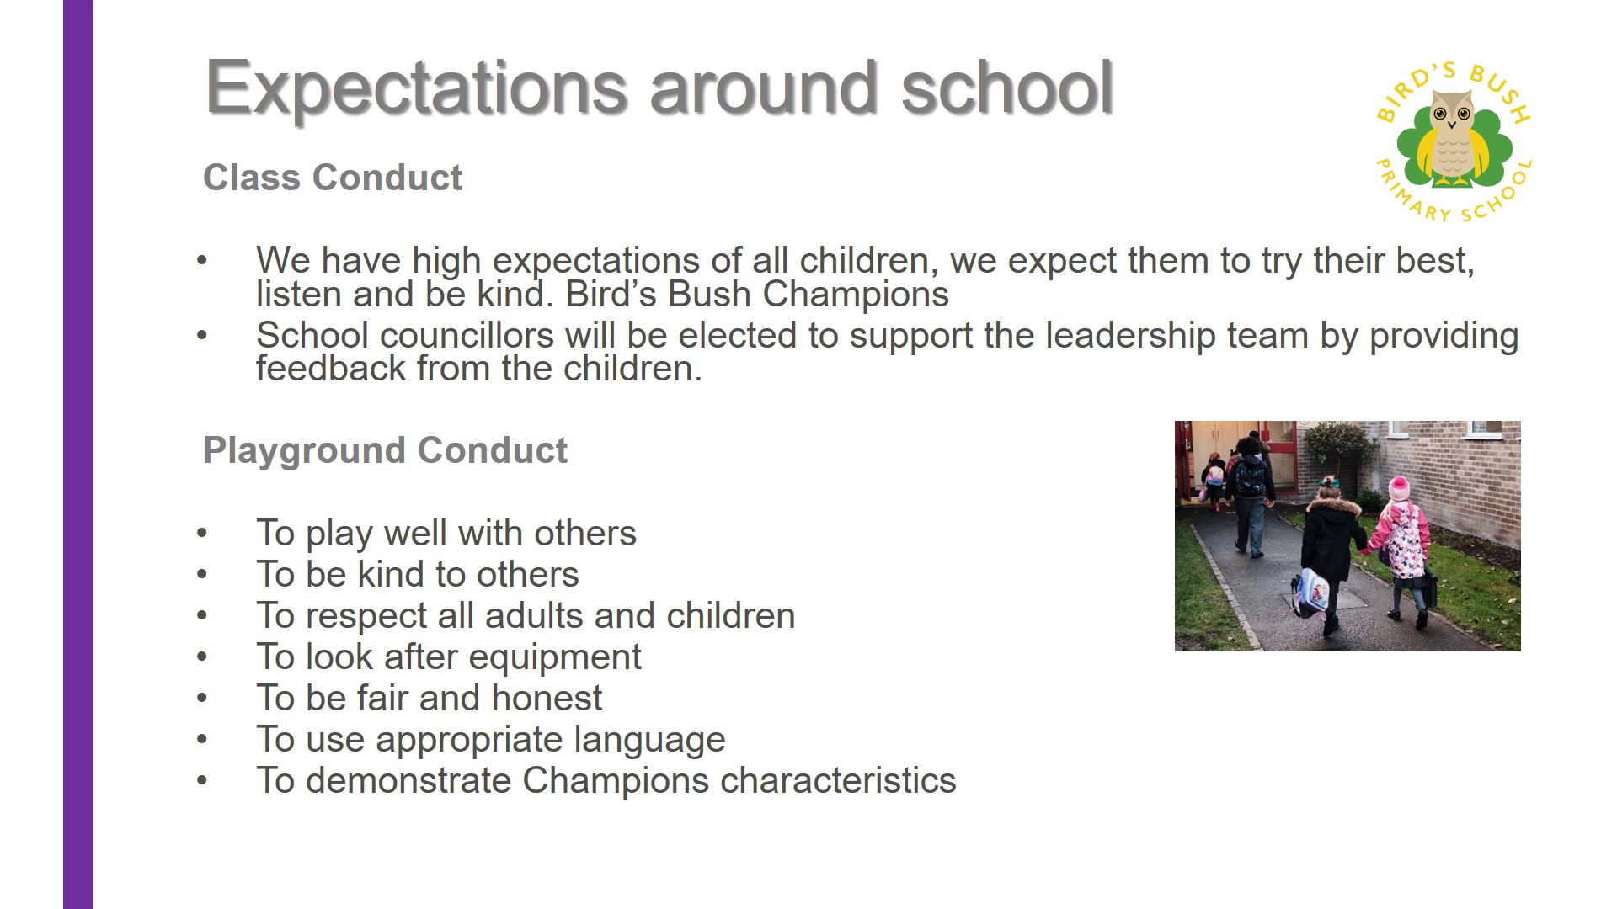
https://sway.office.com/CWmXHfO8oo0mAW9T#content=HnQYREf1siJu9X
2 - Welcome to Year 3
https://sway.office.com/CWmXHfO8oo0mAW9T#content=vtJq9MTHFPDnnU
3 - Welcome to Year 2
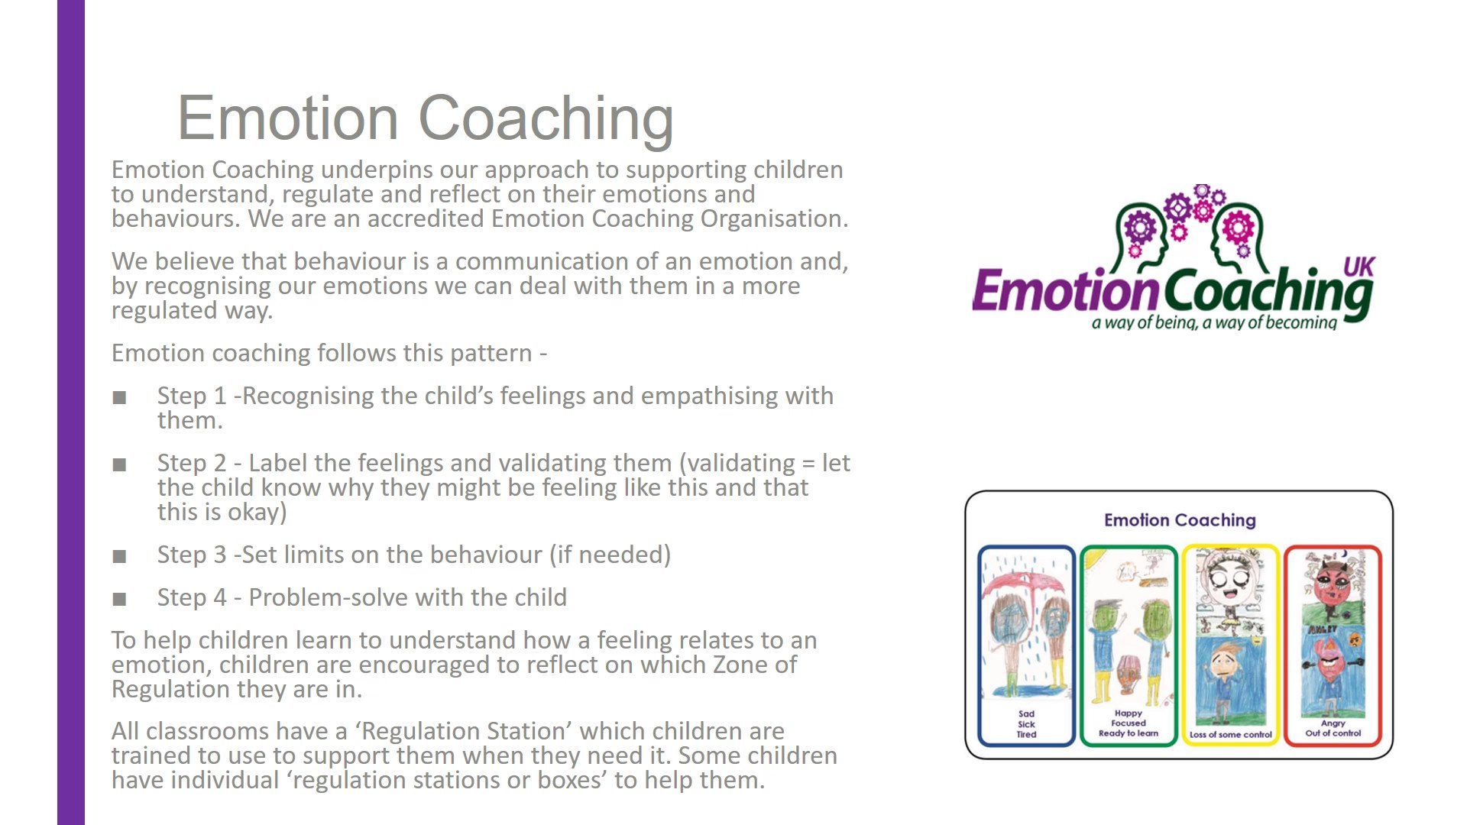
https://sway.office.com/CWmXHfO8oo0mAW9T#content=1H2TxHx2bTxBat
4 - Welcome to Year 1
https://sway.office.com/CWmXHfO8oo0mAW9T#content=4AJ9OzcMDaLZhd
5 - Welcome to Year 5
https://sway.office.com/CWmXHfO8oo0mAW9T#content=iEfZUs8mfvBlMC
6 - Welcome to Year 4
https://sway.office.com/CWmXHfO8oo0mAW9T#content=NO04TEIIsJZghh
7 - Welcome to Year 6
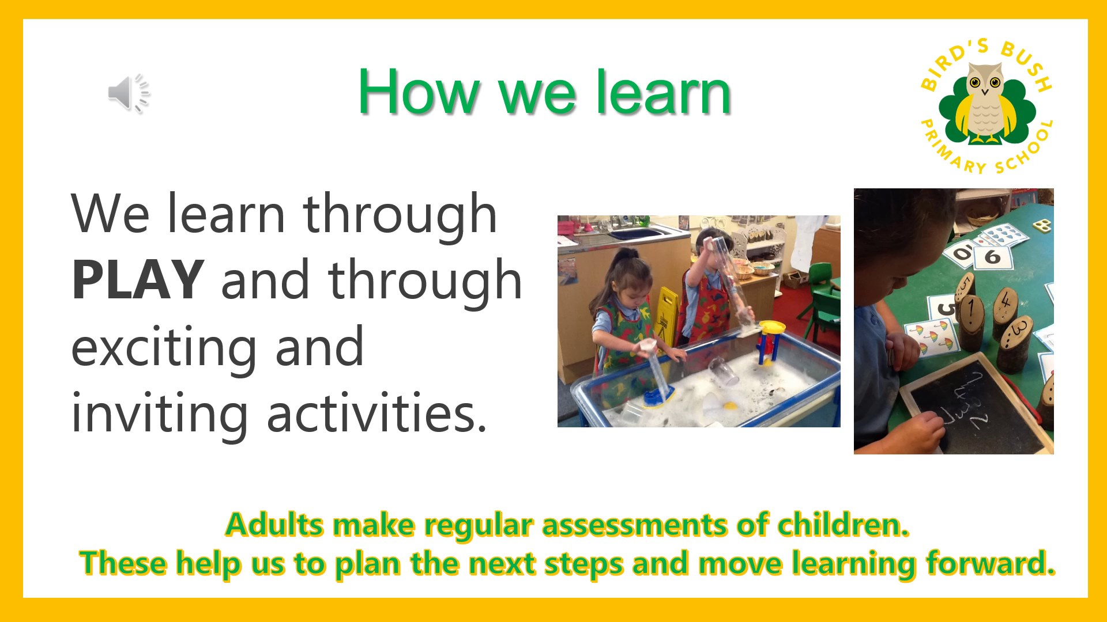
https://sway.office.com/CWmXHfO8oo0mAW9T#content=HBP1vLklG8j6bF
8 - Welcome to Reception at BIG SCHOOL

Next week we will be sending out your Annual Reports through Purple Mash - like we did last year. It has been difficult this year as children have not covered the whole of the curriculum content they should have done in the National Curriculum - because of the move to remote learning in January. We have focussed on the 'critical content' during the summer term but it does mean that children may show as only entering their Age Related Expectations in some areas of learning. This is nothing to worry about, they can't be 'secure' if they haven't covered it yet. Our curriculum will be adapted next year to address these gaps. The progress your child has made and the comments from their teacher say the most about your child this year in school.
Please remember that all children develop and progress at different rates anyway, without the added disruption that Covid has presented us with.
We do not hold a formal Parent Consultation meeting in the summer term as your report gives you the information you need - if you wish to discuss anything with the class teacher, after reading the report, please send them an email and they will contact you.
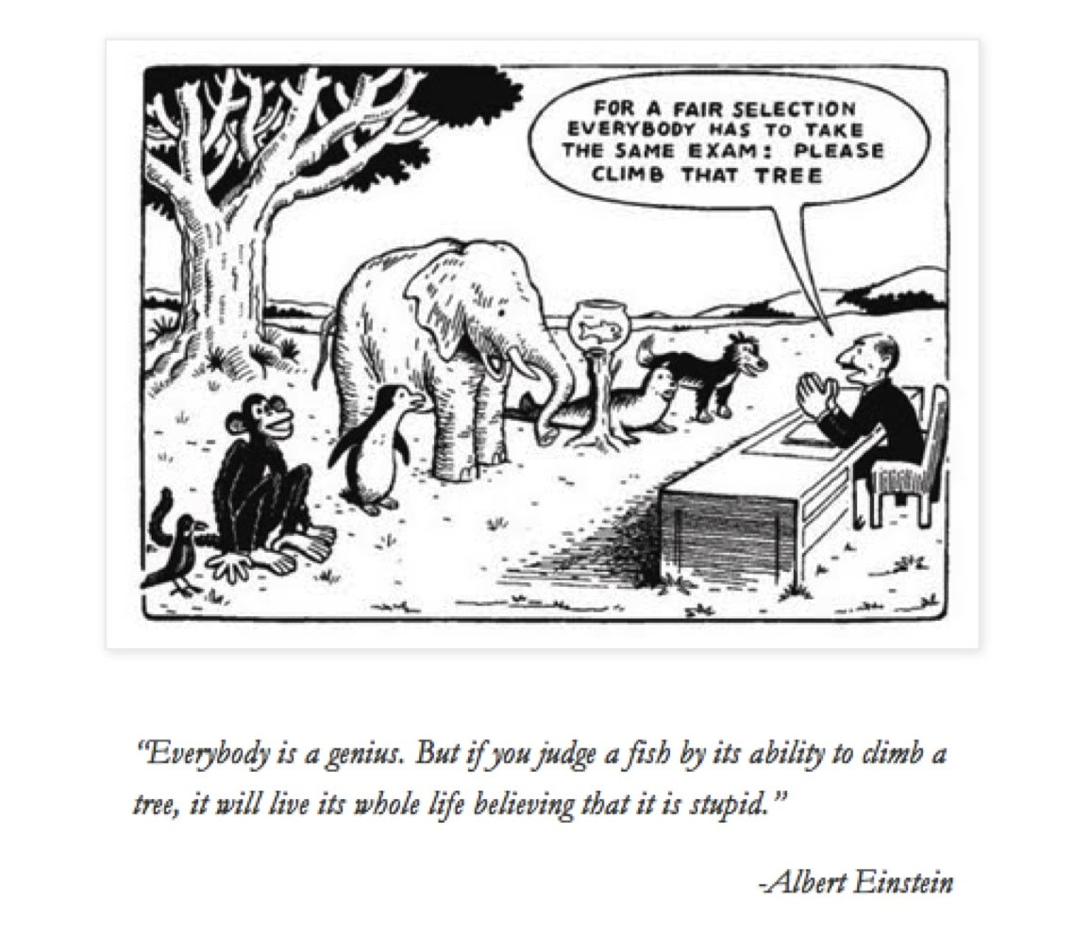

'Read it' Winners
Y6 - Maddison
Y5 - Olivia
Y4 - Lexi
Y3 - Isla
Y2 - Olivia
Y1 - 2 winners next week
RT - 2 winners next week

BIRD'S BUSH CHAMPIONS!
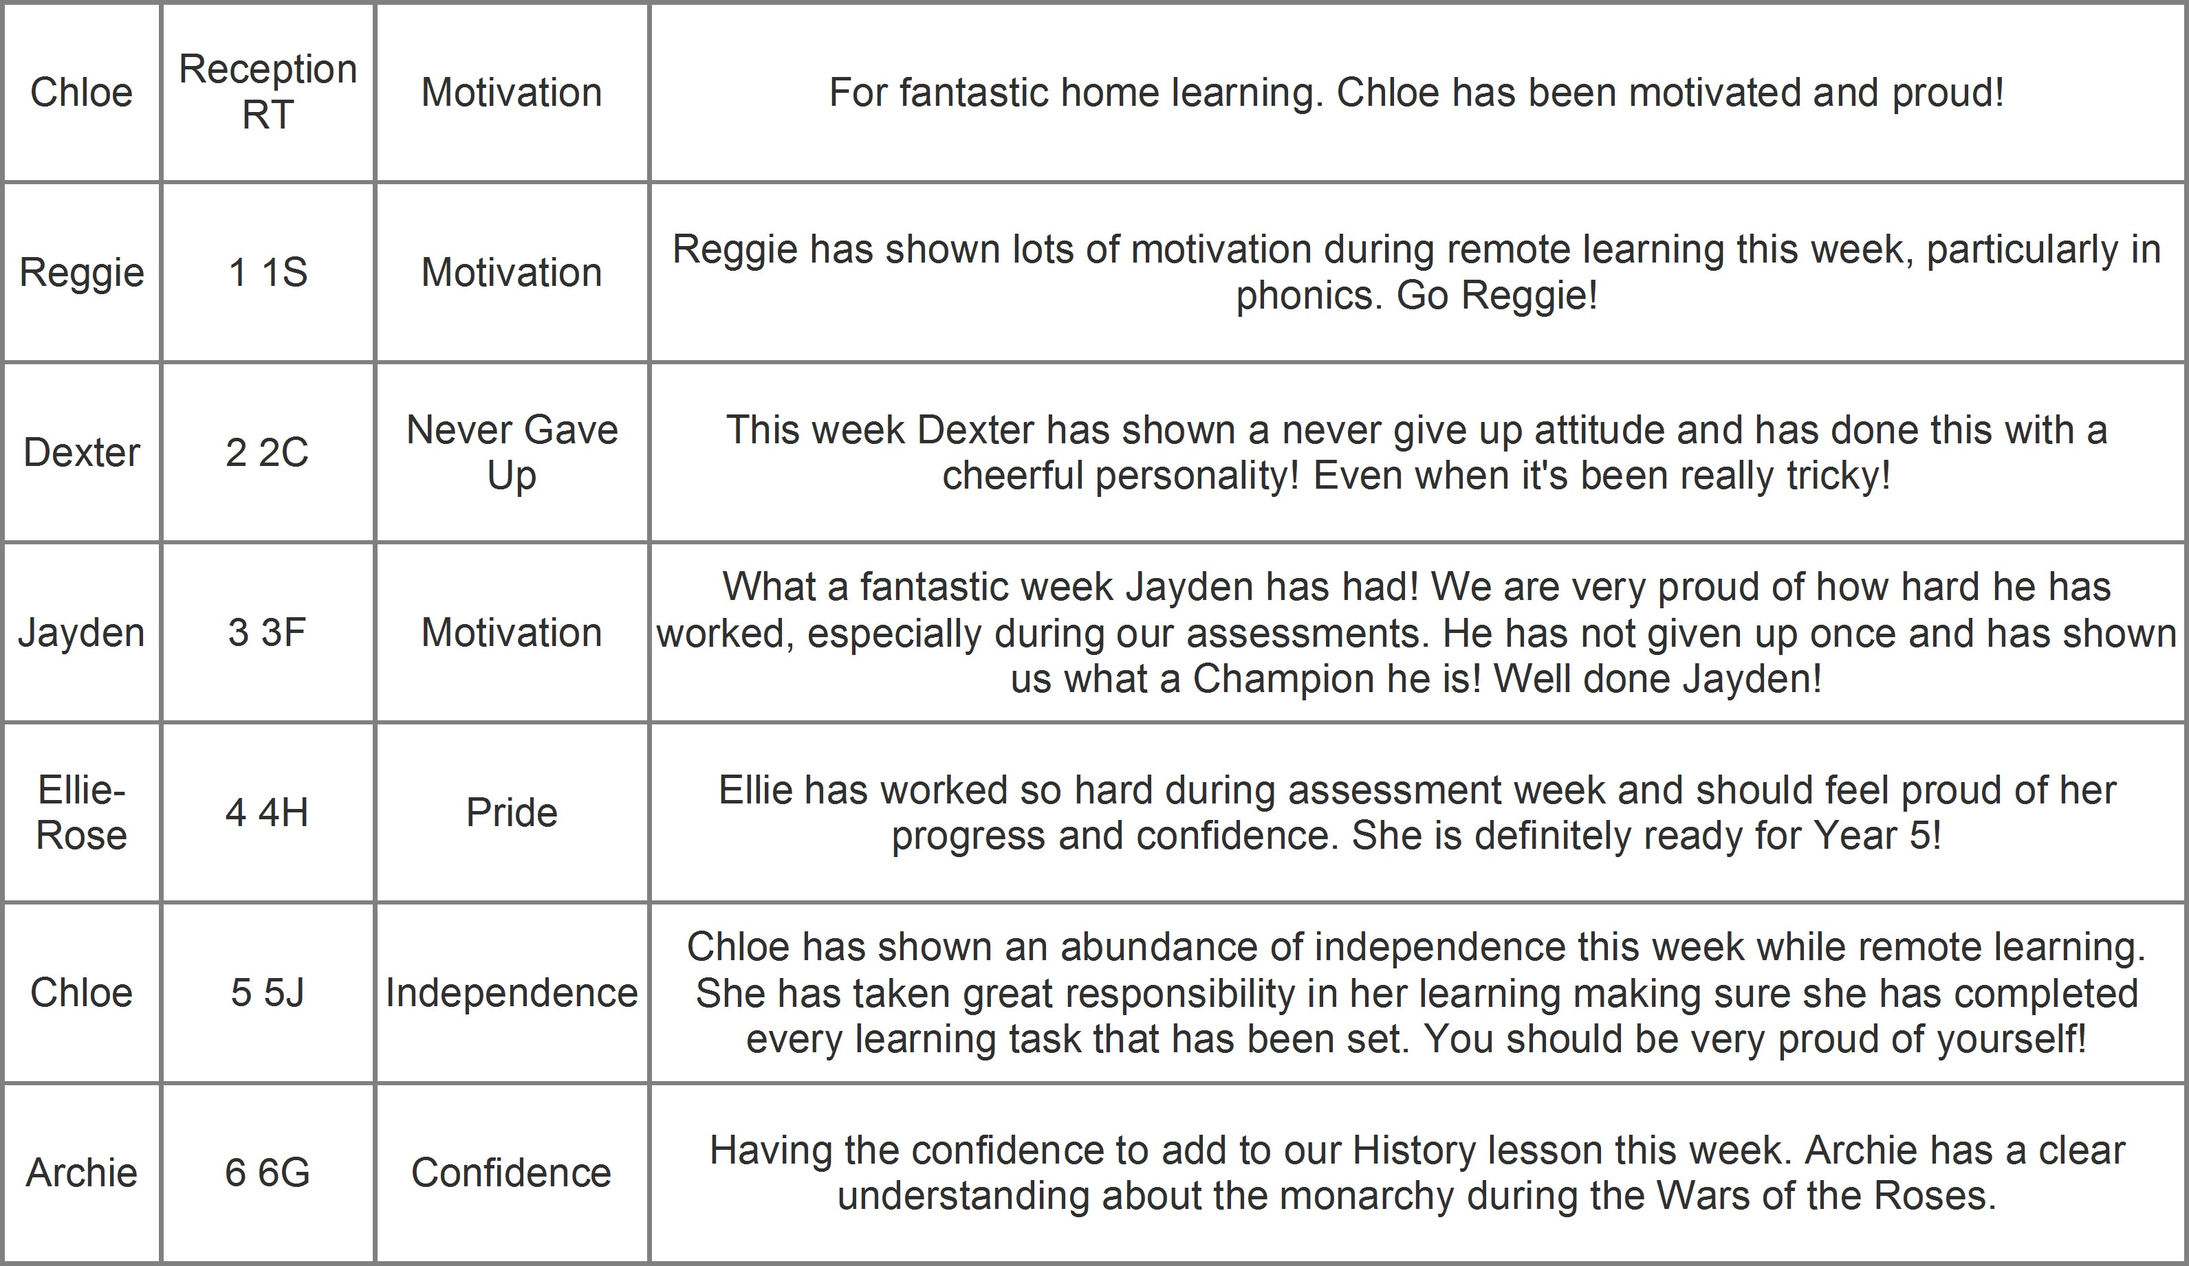

Times Table Rock Stars!
Reception Numberbots - Jaxon
Y1- Henry
Y2 - Isabella T
Y3 - Harrison
Y4 - Zachary H
Y5 - Hannah
Y6 - Ella

School Meals - 3-week menu
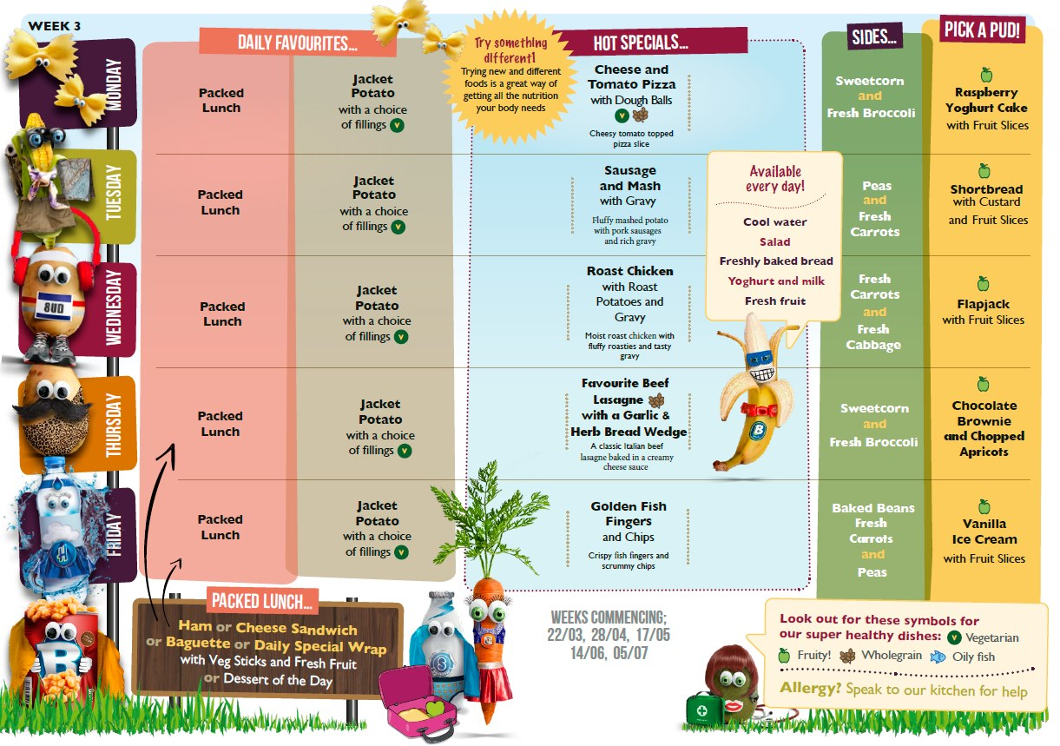
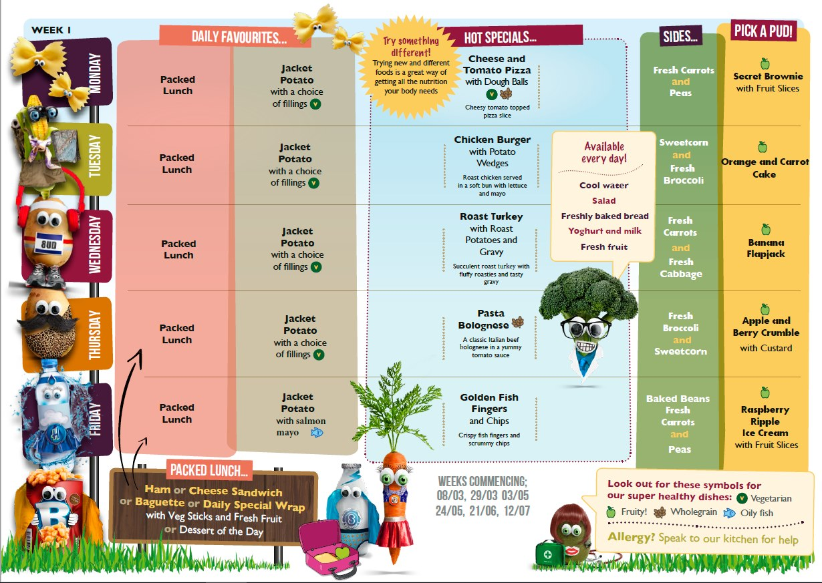
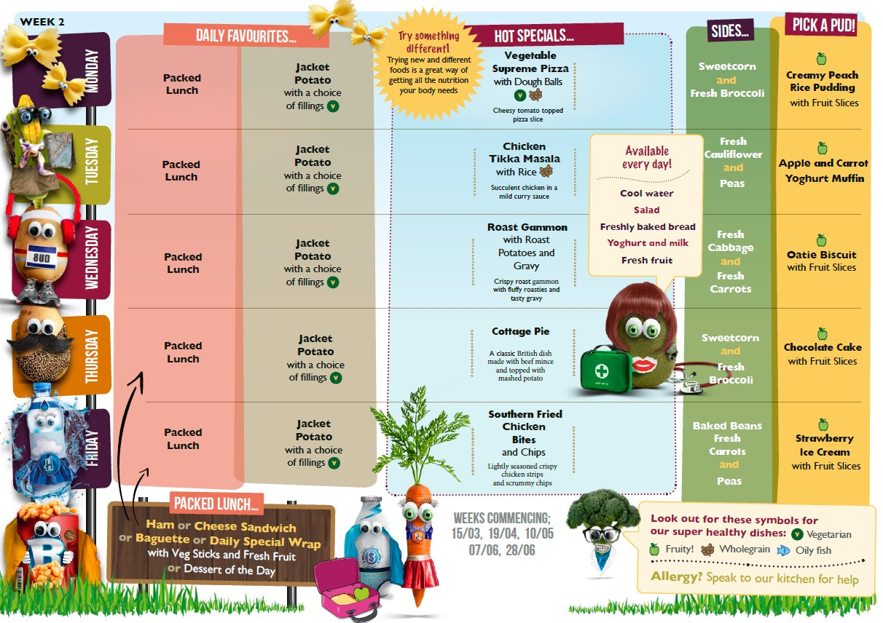

Term Dates for 2021-2022
Autumn Term 2021 - New Reception children have a different start date.
- STAFF TRAINING DAYS: Thursday 2nd & Friday 3rd September 2021
- Term Time: Monday 6th September to Friday 22nd October 2021
- Half term: Monday 25th October 2021 to Friday 29th October 2021
- STAFF TRAINING DAY: Monday 1st November 2021
- Term Time: Tuesday 2nd November to Friday 17th December 2021 Spring Term 2022
- STAFF TRAINING DAY: Tuesday 4th January 2022
- Term Time: Wednesday 5th January 2022to Friday 18th February 2022
- Half term: Monday 21st February 2022 to Friday 25th February 2022
- Term Time: Monday 28th February 2022 to Friday 8th April 2022 Summer Term 2022
- Term Time: Monday 25th April 2022 to Friday 27th May 2022
- Half term: Monday 30th May 2022 to Friday 3rd June 2022
- Term Time: Monday 6th June 2022 to Thursday 21st July 2022
- STAFF TRAINING DAY: Friday 22 July 2022

PLEASE NOTE; these dates are set by our Multi Academy Trust and slightly differ from Staffordshire County Council published dates for 2021/2022, only by 1 day at the start of the year and 1 day at the end of the year so it shouldn’t impact on holiday dates set by local schools.
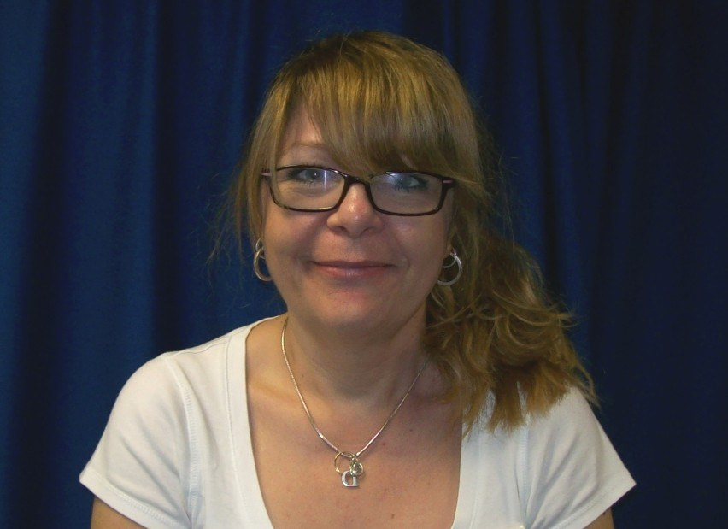
9 - Denese Hill - Family Support Worker
Denese is available for help and support during this time. Just drop her an email and she will be in touch. d.hill@perryhallmat.co.uk
Denese has launched a new Facebook group for parents. She can no longer access the 'unofficial' parents page that has been going for a few years, so she won't be able to help and answer your questions or post any reminders or updates on there anymore. The group always seemed to work well to help to keep you up dated and ask/answer questions, but without Denese on there she cannot do that anymore and we don't want you to lose that communication.
Please join the new group as it is a really useful way of keeping up-to-date with things in school. The newsletters will also be posted in the group as well. The group is not "censored", it is there to help and keep people connected. The usual rules of treating everyone with respect and courtesy apply - if you have questions, it's a great place for information and advice, if we have any celebrations, it's perfect to share them - if you have worries or complaints, please speak to us directly or PM Denese.
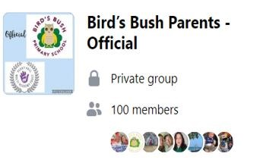
Click here to join the group

Bag2School is a trading name of Next Best Clothing Ltd, the largest textile collection company working with schools in the UK. Founded in 1999, it has now paid over £27 million to schools, nurseries, playgroups, pre-school groups and churches and diverted thousands of tonnes of clothing from landfill. With trading stablemate Bag2TheFuture, it provides a free fundraising service for anyone wanting to raise funds using a resource EVERYONE has got in their wardrobe – unwanted clothes.
What can be included in the collection? We are collecting good quality items for RE-USE:
- Men’s, Ladies’ and Children’s clothing
- Paired shoes (tied together or elastic band around)
- Handbags
- Hats
- Bags
- Scarves and ties
- Jewellery
- Lingerie
- Socks
- Belts
- Soft toys
- Household linen
- Household curtains
- Household towels
- Household bedding (bed sheets, pillow cases and duvet covers)
We DO NOT accept:
- Duvets and blankets
- Pillows and cushions
- Carpets, rugs and mats (including bath, shower and toilet mats)
- Soiled, painted, ripped or wet clothing
- School uniforms with and without logo
- Corporate clothing and work wear
- Textile off cuts, yarns or threaded material
Our school collection: please can you bag things up during the summer holidays and bring into school on 14th September 2021. Only this day please due to storage issues. We are very grateful for your contributions!
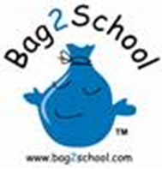
Wild World Heroes, Summer Reading Challenge 2021 is a celebration of nature and action for the environment, in partnership with WWF UK.
This year children will only need to make two visits to the library. On the first visit they will sign up for free, receive their starter pack, and select 6 library books. Once they have read the books or had them read to them, they bring them back and receive their rewards including a medal. You can sign your child up for the challenge from July 10th 2021.

STAY SAFE XXXX GOOD LUCK TEAM XXXXXX

