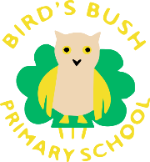
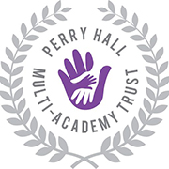
What have we been learning in Early Years this week?
29th – 1st April 2021
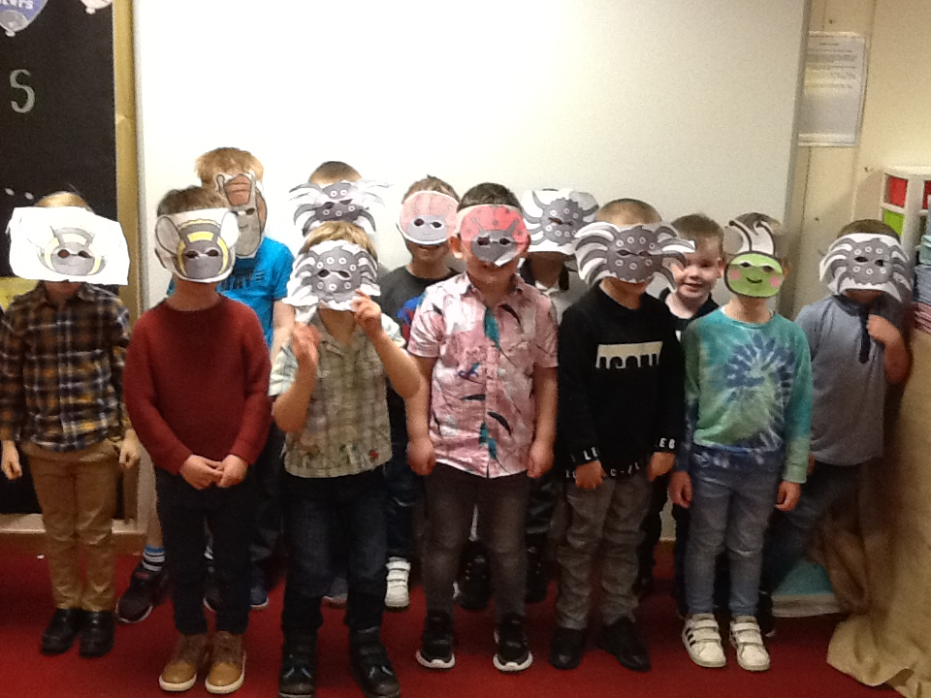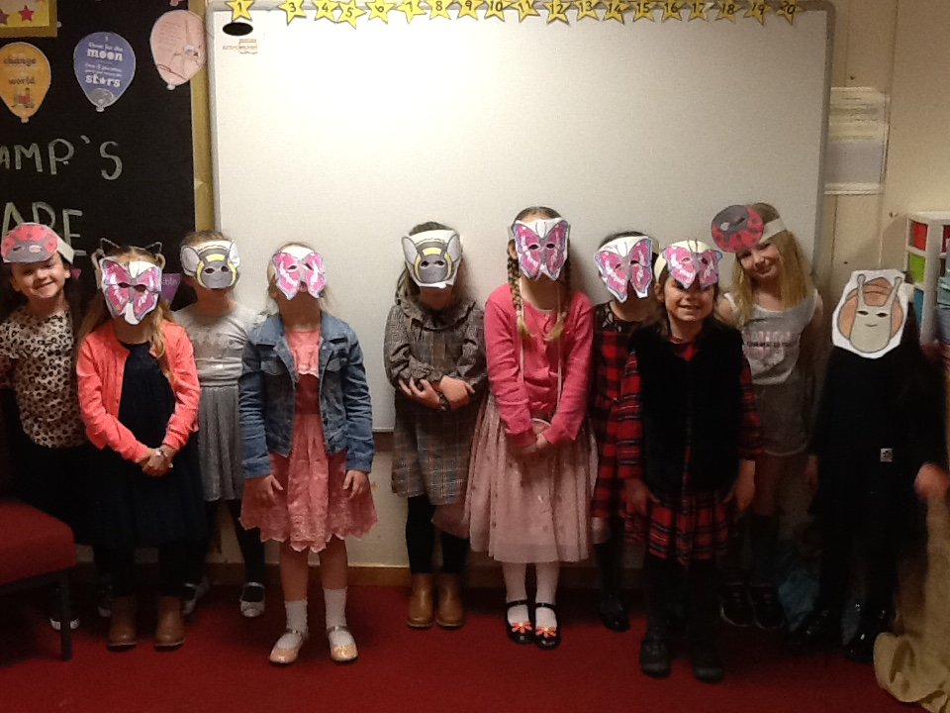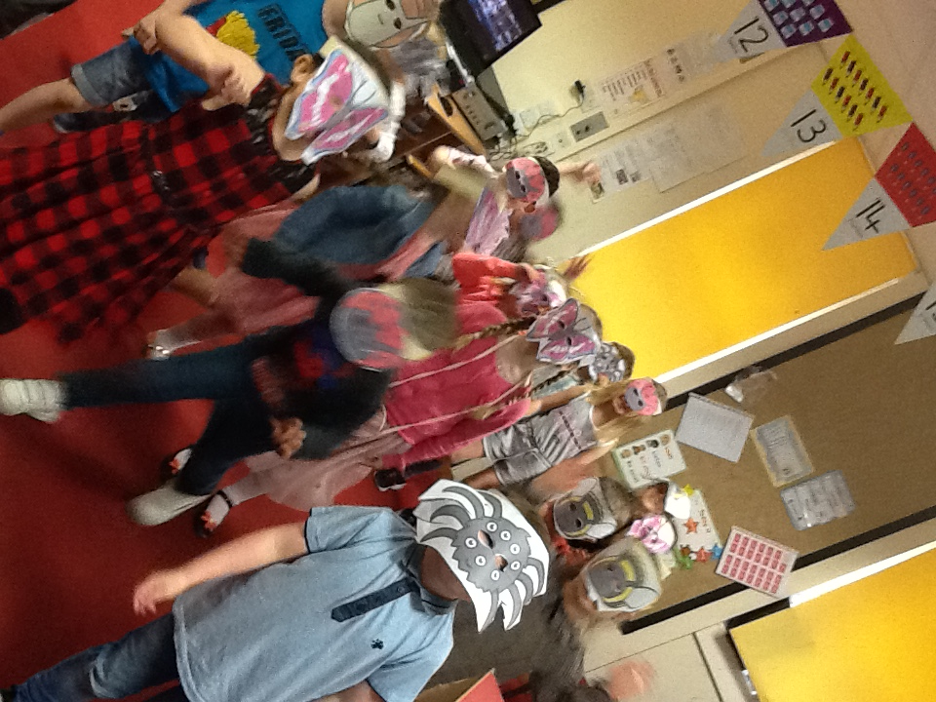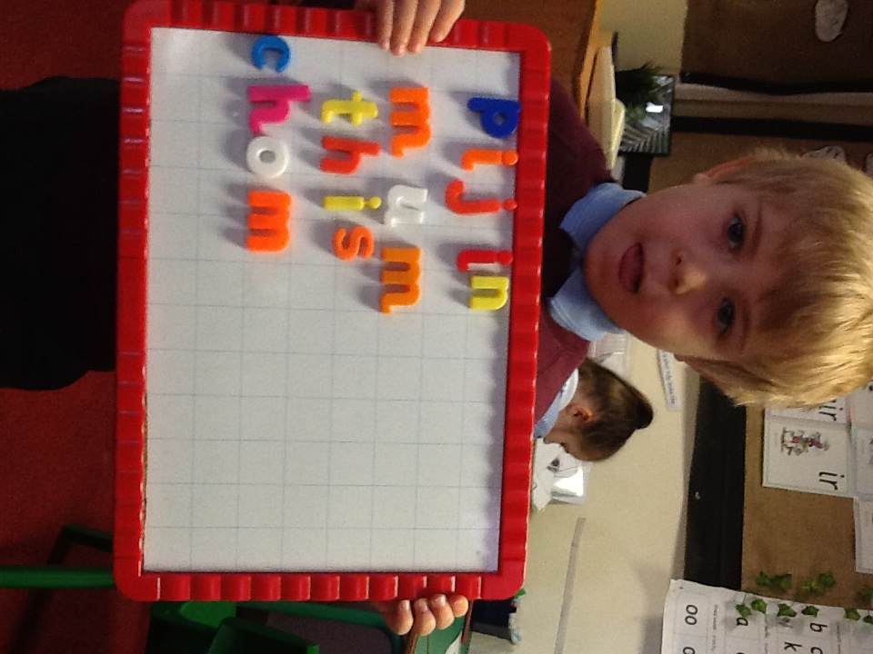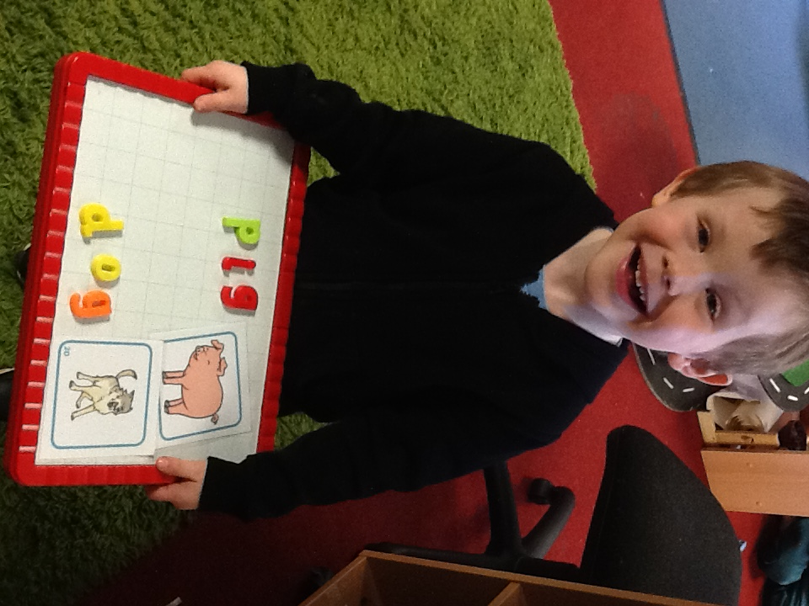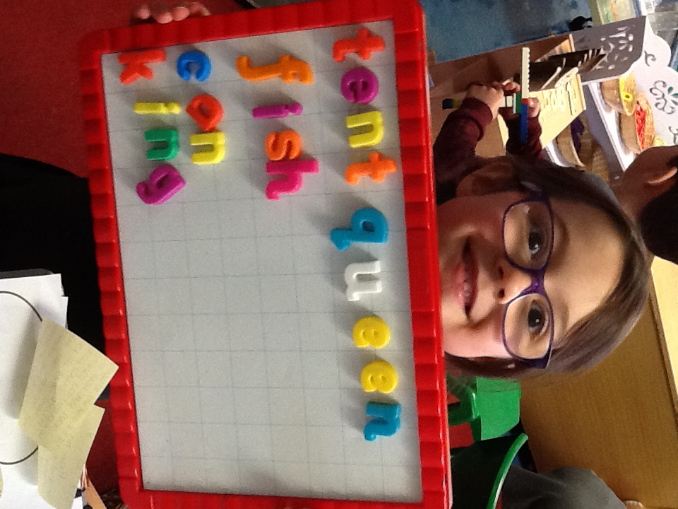After half term we will still be doing PE on the Tuesday that the children return, so the children need to come to school in their PE Kits.
Lots of the children are now applying their phonics to their independent reading and writing. We have been so impressed by their independent learning that we had to share some with you on the newsletter this week!
Read Write Inc
Miss Thornton’s sounds this week: o, c, k
Please continue to practise Fred Talking at home, here is a video link to a Fred talk game: https://schools.ruthmiskin.com/training/view/qDCEGVuD/dLmumJGJ
Miss Hazelton’s group are now consolidating special friends: sh, ch, th, ng, nk, qu
Please continue to practise these at home and read the sound blending books with the children. After half term, they will be reading red books.
Mrs Holmes group will be moving on to set 2 sounds after half term and will be reading pink books.

Mathematics
In Maths this week we have been consolidating one more and one less. The children are doing a brilliant job with this, and many were able to complete my one more one less challenge independently! We were very impressed. Some children still need support with one less and that is ok, we will be revisiting this later in the summer term.

The children have absolutely loved our Ugly Bug Ball for our Fabulous Finish! They wore their headbands that they created earlier in the week and engaged in a variety of party games. We impressed Debbie at lunchtime with our fantastic outfits!
After half term.
RWI | Mathematics | Provision
Miss Thornton’s Group will continue to focus on set 1 sounds and blending.  Miss Hazelton’s Group will continue to recap special friends and will start red books.  Mrs Holmes Group will be learning set 2 sounds and reading pink books. | After half term we will be consolidating addition and subtraction for the first two weeks back. We hope all children will then be able to add and subtract two single digit numbers. We will be using manipulatives to help the children and will also be showing them number sentences. | Our topic after half term is ‘Let’s Grow’. We will be launching our topic with a Stunning Start where we will be having a Gardening session. You may want your child to bring Wellies in if they don’t already have them in school.  We will be using quality texts to enhance our learning such as Jasper’s Beanstalk and Jack and the Beanstalk as well as many Non-Fiction books about life cycles.

