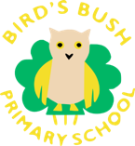

RWI Books

Black and White RWI Books
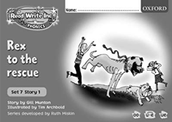
Your child learns to read through an exciting and structured programme called Read Write Inc. Each week, your child learns to read a new book that is closely matched to their phonic knowledge and reading ability. Throughout the week, they read the story three times. This allows them to move their concentration from decoding the words, to understanding what is happening in the story to reading the story in their best storyteller voice. Your child will be bringing home a black and white version of the storybook they have worked hard to read that week in school after their third read. They will be able to read this story with fluency and understanding and this is exactly what we want for our children. We want them to be able to use this as an opportunity to confidently share their fantastic reading with you at home.

From Week 4 of the Autumn term, your child will also be bringing home a previously read black and white book to encourage them to re-read familiar stories and continue to develop their confidence and fluency.
There are instructions at the beginning of the books about reading these stories at home with your child.

Book Bag Books
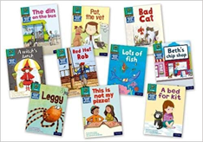
Your child will also be bringing home a ‘Book Bag Book’. This story is linked to the book they have been reading that week in school. It may contain the same character or a similar setting. Your child may not be able to read this story as fluently as the black and white book they are bringing home as it will be the first time they will have read it. However, it contains the same sounds they have been learning to read that week so it is good practise for them and it is a good opportunity for you to encourage and support your child’s reading journey at home.
The Book Bag Books will be sent home every other week as they are shared between the children.

Black and White Books and Book Bag Books will be sent home in a named plastic wallet. They will be changed every Friday. Please ensure your child’s named plastic wallet of books and reading diary are in school every day so they can read it to the adults in school.

Thank you for taking an active role in your child’s reading journey.
Miss Smith
RWI Leader

