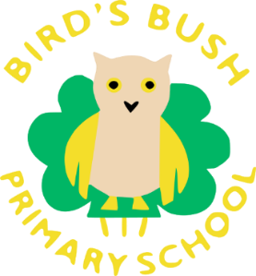
RWI Books
Dear Parent/Carer,

Your child can now read all (or nearly all) single letter sounds and they are now learning how to read Special Friends (two or more letters that join together to make one sound). The sounds your child is going to be focusing on are th, nk, ng, ch, ck and qu.
As a result of this, your child has started reading their first Read Write Inc book during their phonics lesson! These are known as ‘Paper Ditties’. This is a very exciting time for the children as they are now having the opportunity to read full sentences rather than individual words.
In order to support your child’s reading journey further, the children will be sent home with the paper ditties they have read in class this week in their RWI wallet every Friday. On the following Friday, these will be changed and the old ones can be kept at home for re-reading. Please ensure they are in school every day so the children can read with an adult.
This is an opportunity for your child to show you their amazing reading skills. Below are the steps the children are becoming familiar with when reading their paper ditty:
- Read the sounds at the top of the page one at a time.
- Fred Talk (sound out) and read the words at the top of the page.
- Fred Talk and read the paper ditty.
The National Curriculum states that children will build fluency and a love of reading through re-reading well-known and familiar texts. Therefore, your child can practise reading their ditty as often as they would like to. Every time you read a ditty, please write it in your child’s reading diary so they can receive ‘read it’ tickets.
The children are very excited to share their reading journey and successes with you.
If you have any questions, please do not hesitate to contact me or you child’s class teacher on the class email system.
Miss Smith
RWI Leader

